Washtenaw Community College
ASSESSMENT REPORT
CurricUNET Training
Revised January, 2019

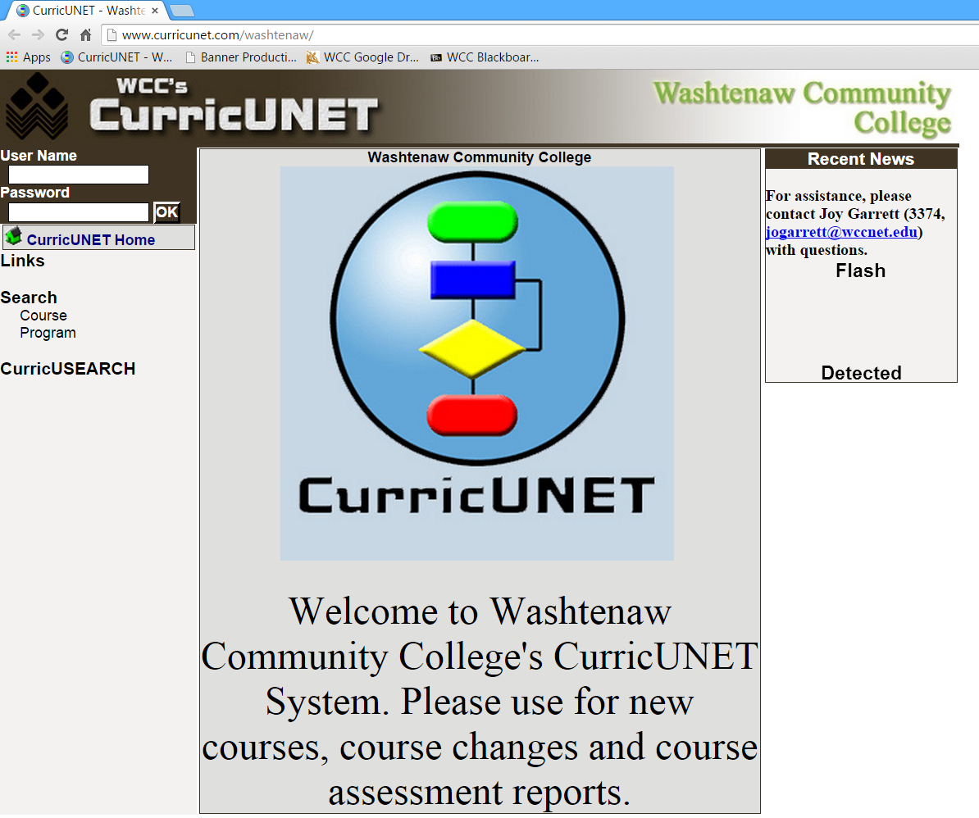
In CurricUNET, select Assessment Reports
Screen appearance is much like “My Courses”. Under Assessment Area, use the dropdown box to select your valid subject code.
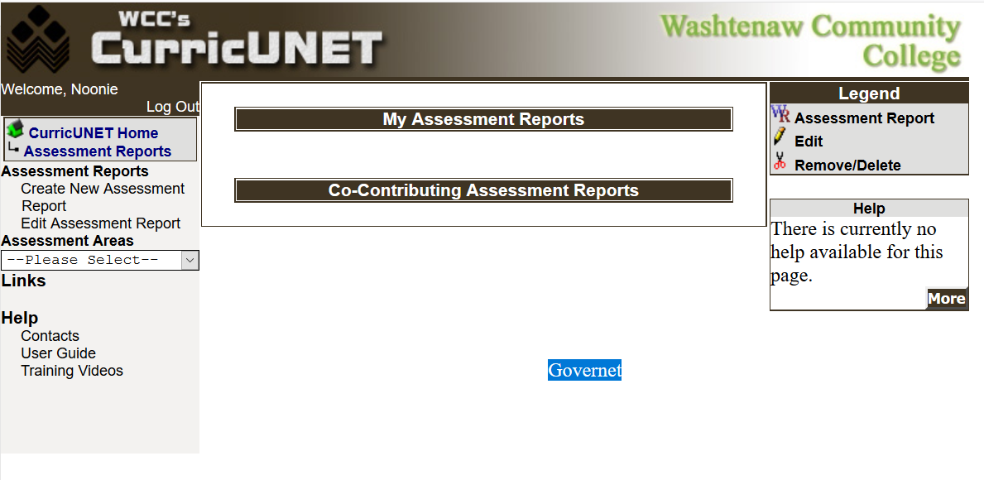
To create a new assessment report, select the ACTIVE version of the subject and course number and click “SAVE”
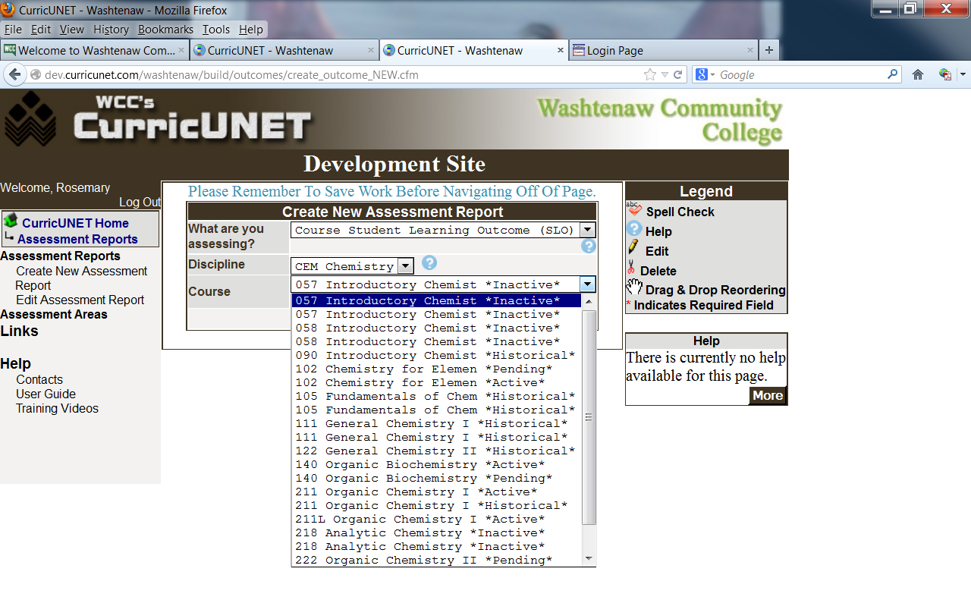
You may add co-contributors on main menu so that multiple people can contribute to the report.
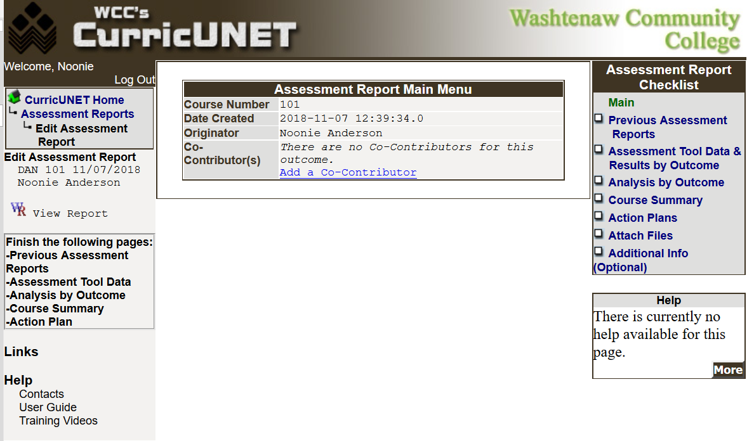

From this main menu, you will work to complete the assessment report.
Use the Assessment Report Checklist in the right column to navigate from screen to screen. To select a screen, click on the WORDS (not the check box).
Use the information in the left column to determine what needs to be “finished” prior to submitting the assessment report. As the forms are “finished”, a check mark will appear in the right column next to the screen name and the screen name will drop off the screen listing in the left column.
Complete the forms one at a time.

Select Previous Assessment Reports from the Assessment Report Checklist.
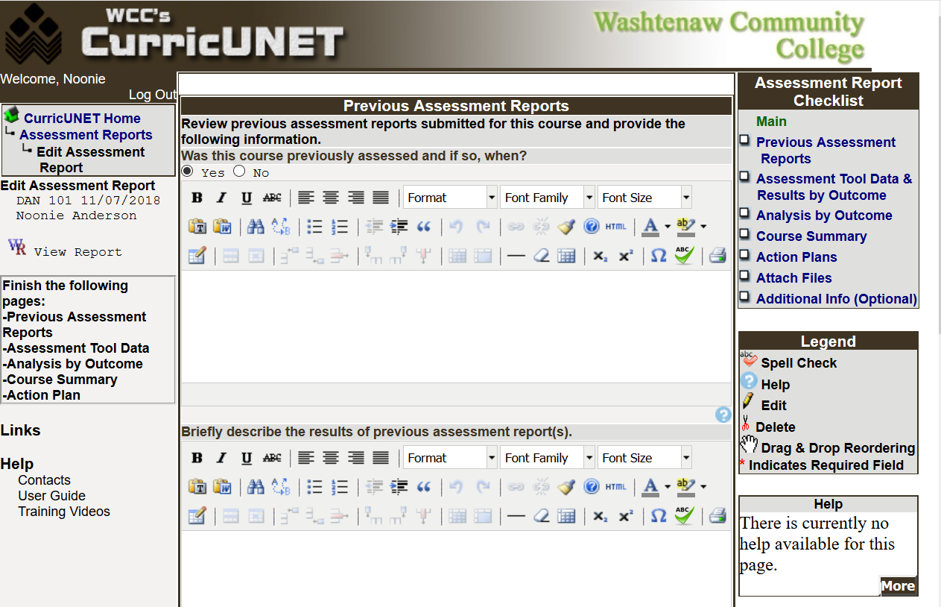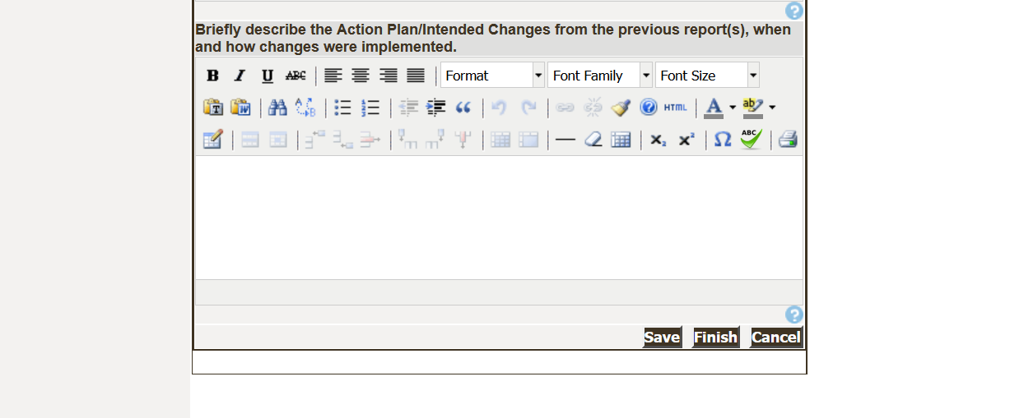
Select the radial button, either Yes or NO in response to the question: Was this course previously assessed and if so, when?
If it has not been assessed, select “No” and click “Finish”. If it has been assessed, click “Yes” and input responses for the three questions listed below.

Select Assessment Tool Data & Results by Outcome.
Complete one form for each combination of outcome and tool. For example, if outcome #1 has two tools, you will create this screen twice, once for outcome #1 with the first tool and once for outcome #1 with the second tool. See the example below:
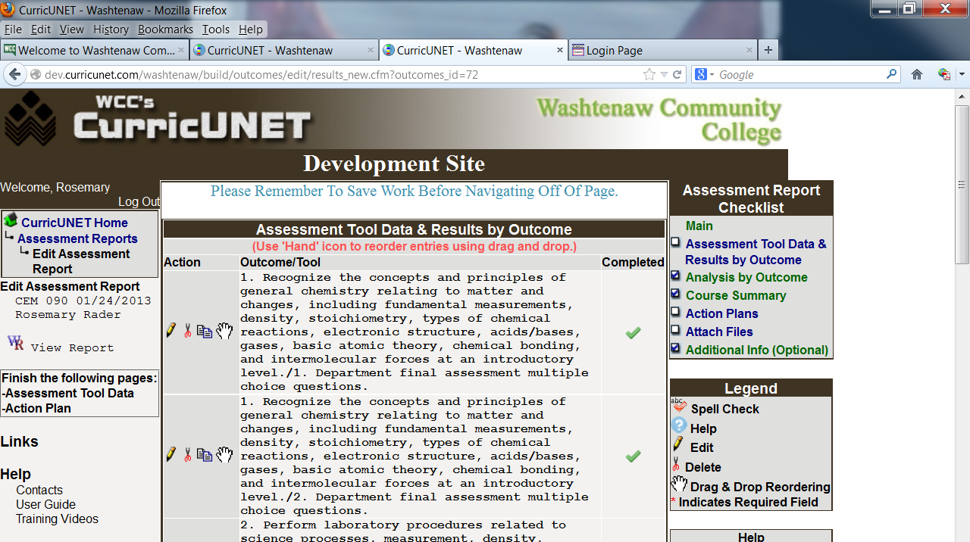
Once you click “save” or “complete” the data will roll up into the summary section in preparation for you working on the next outcome/tool combination. To update the information, click on the Edit icon.
Other icons that may be useful are 
Delete allow you to delete the outcome/tool combination
- Drag and Drop Reordering allows you to move the order of the outcome/tool combination

Copy allows you to copy the text of one outcome/tool combination to another. If the assessment information is similar, you can copy the text and edit as a way to speed up the process.
On the Assessment Tool Data & Results by Outcome, select the outcome and tool combination you want to update.
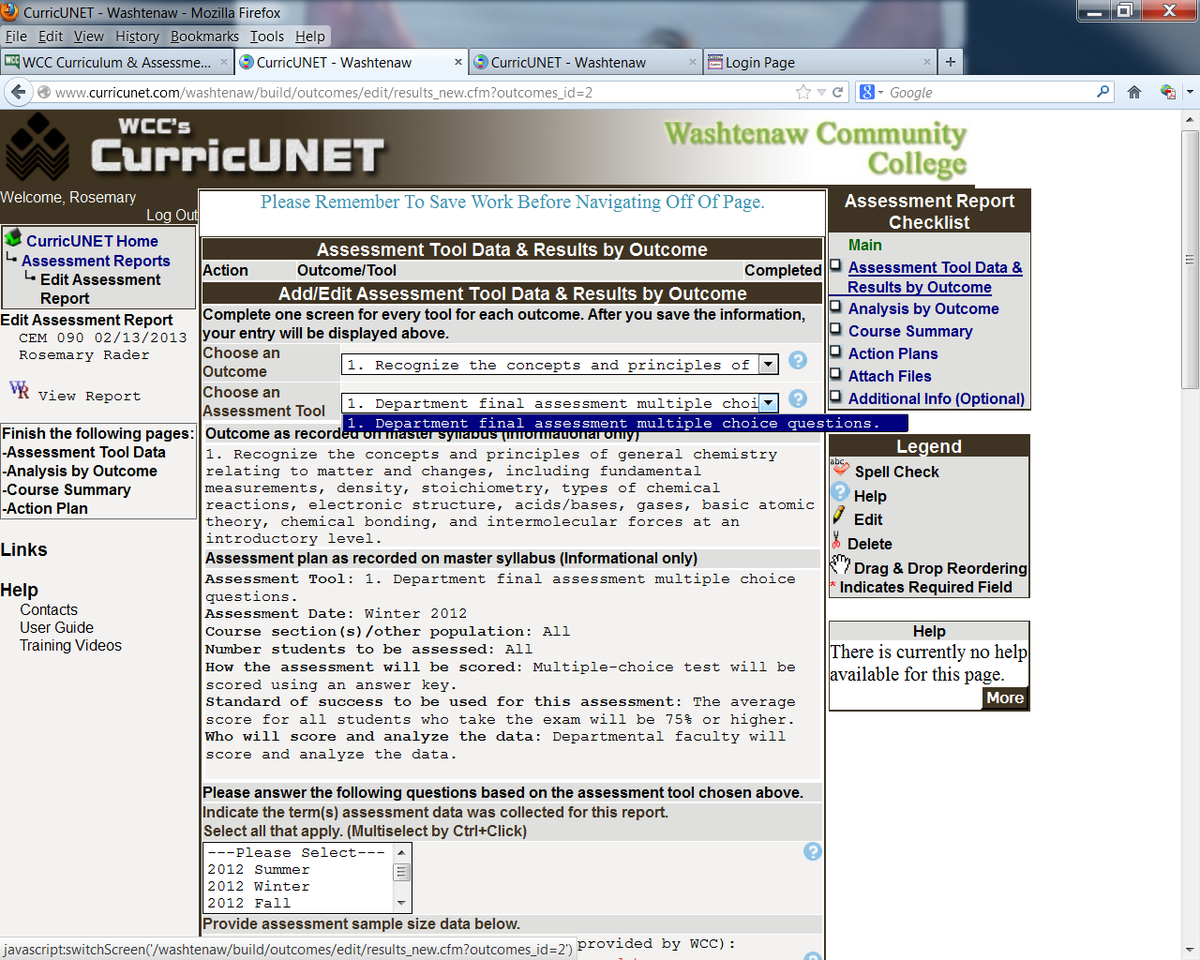

Once selected, the Student Learning Outcome and the Assessment Plan, recorded on the master syllabus will appear. You may not edit these fields. Make corrections to the information when you update the master syllabus.

Data that comes from CurricUNET is identified below with the . You cannot update this text.

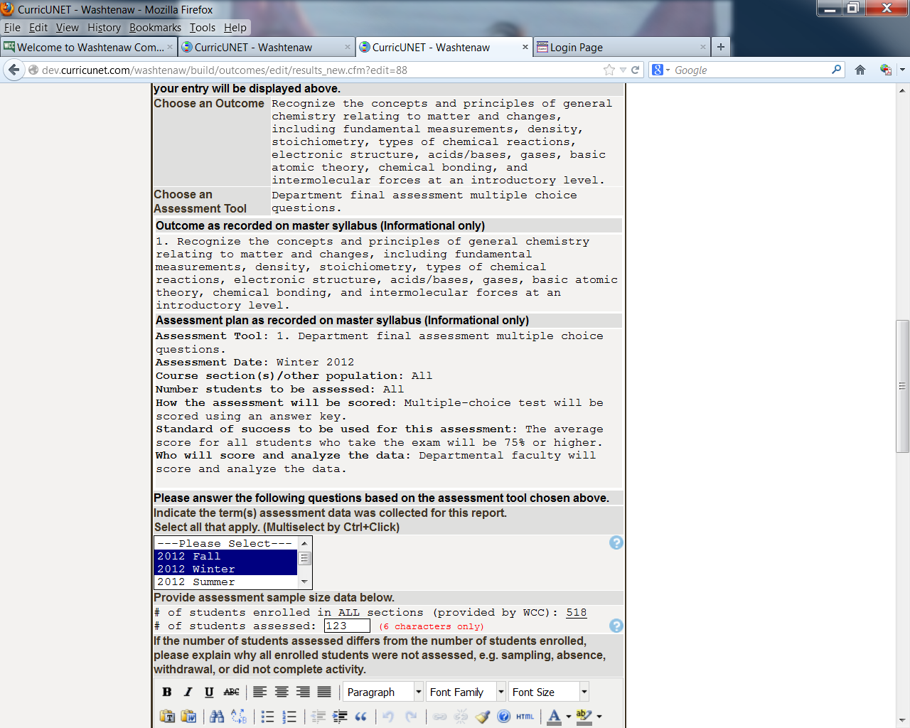
Input the number of students assessed
Select all semesters assessed
This information is provided for you

You may save the form from this point forward using “Save as Incomplete”. The form will be available to you to revise and update.
Continued
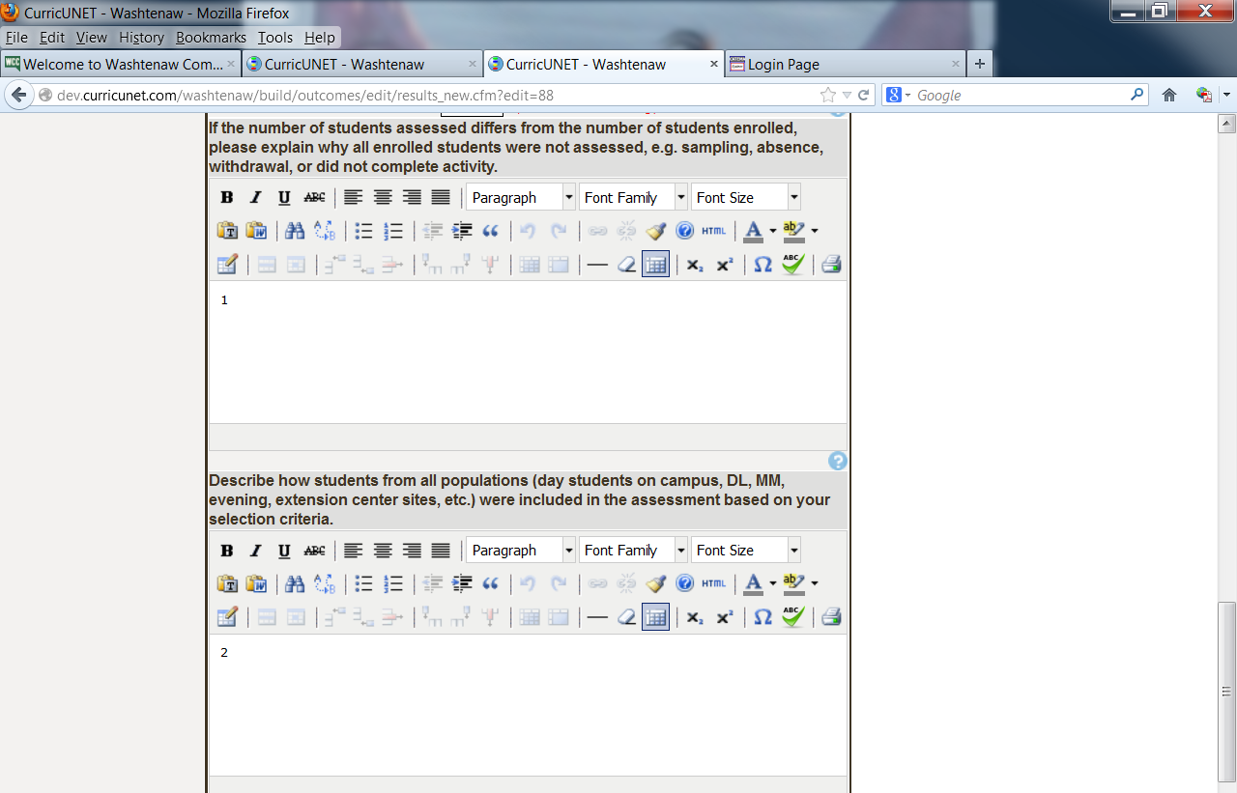
Use this space to describe the difference between the number of students enrolled and the number assessed.
Use the space for the second question to describe how students from multiple populations were selected. It is important that students are selected from all formats such as face-to-face, mixed mode and online. In addition, students from day and evening section should also be included in the assessment process.
The answers to these questions should be limited to the results for this outcome for this tool.
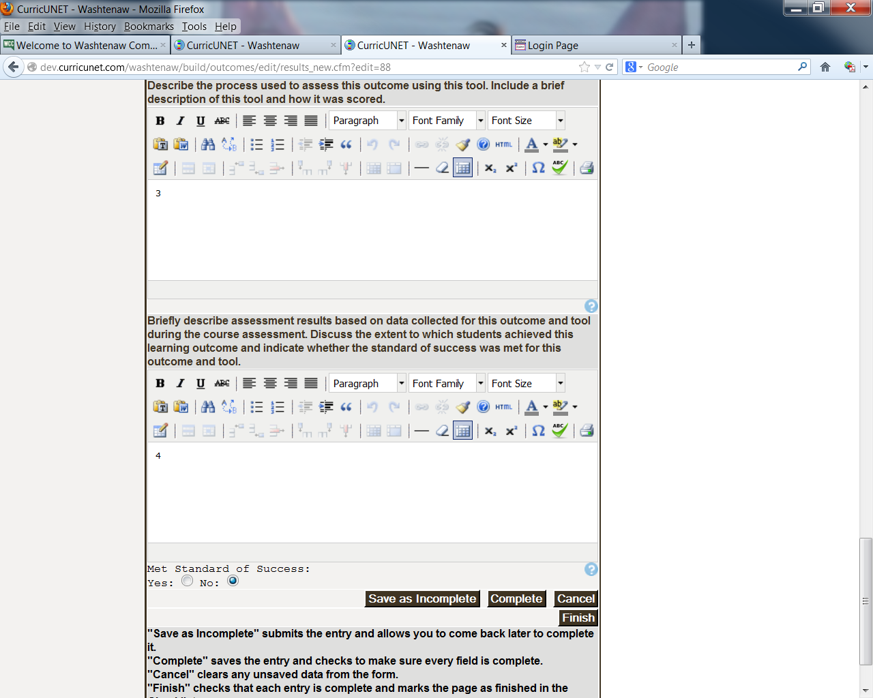

Error messages will appear if you attempt to complete a form without all of the fields populated.
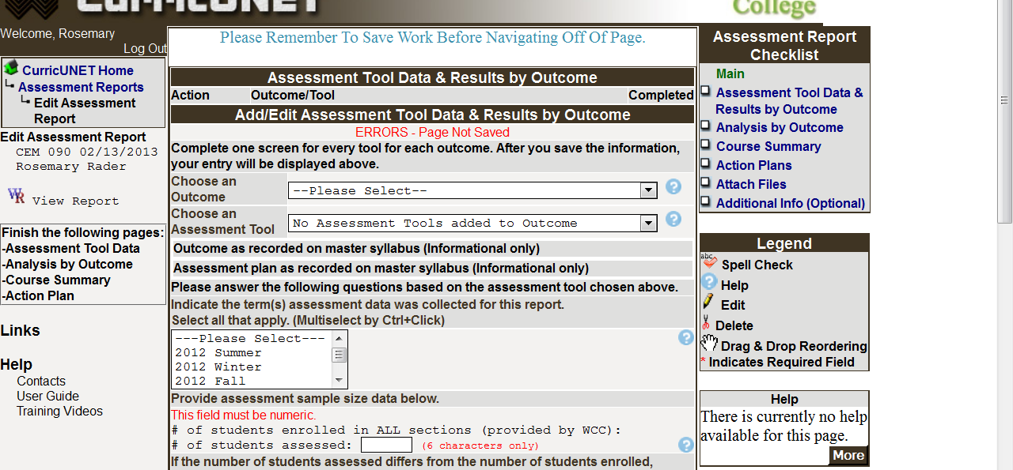
Repeat Assessment Tool Data and Results by Outcome until all outcomes and tools have been reported.
When an outcome is marked as complete, you will see a check mark to the right of the outcome.
When all outcomes are complete and you should click “Finish” and the Assessment Report Checklist in the right column will be checked off.

Select Analysis by Outcome from the right column. Complete one form per outcome.
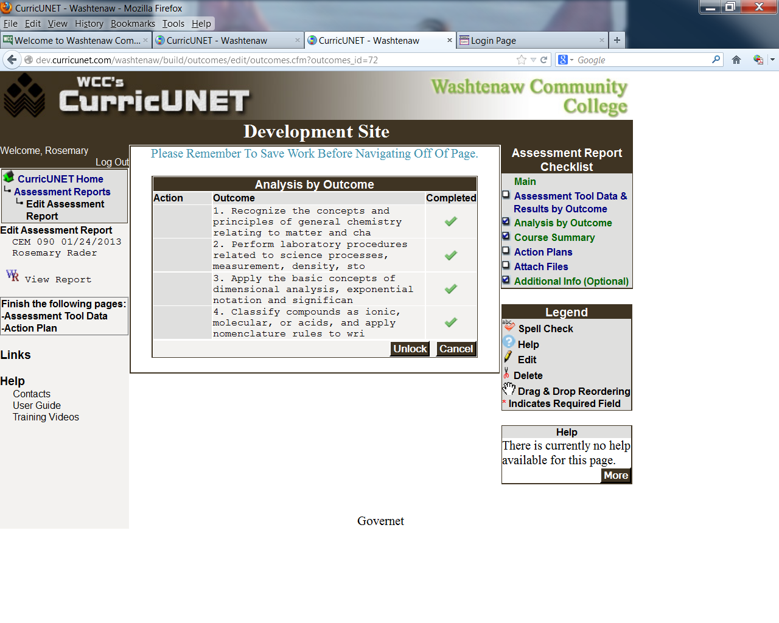
When an outcome is marked as complete, you will see a check mark to the right of the outcome.
When all outcomes are complete and you click “Finish” the Assessment Report Checklist in the right column will be checked off.
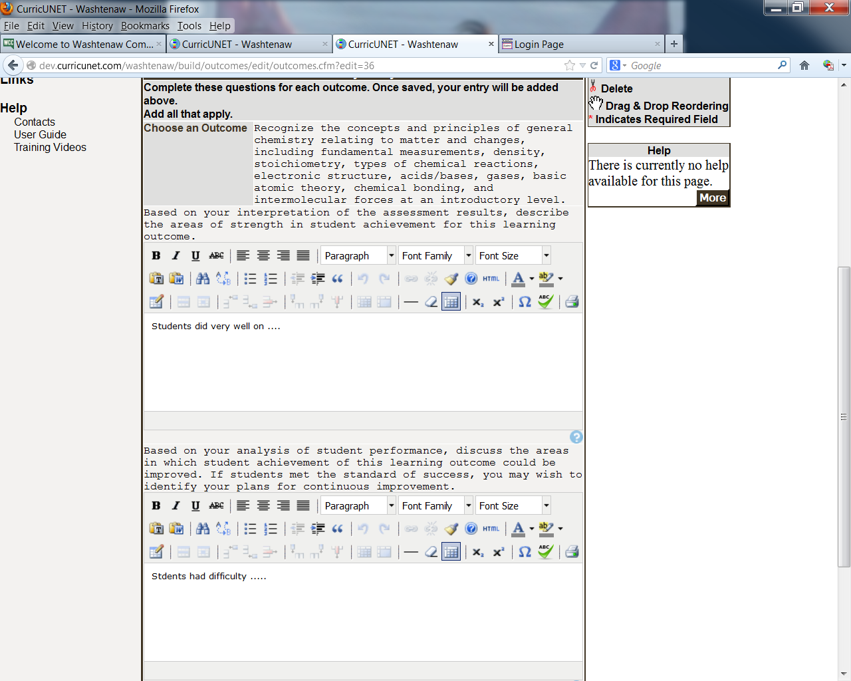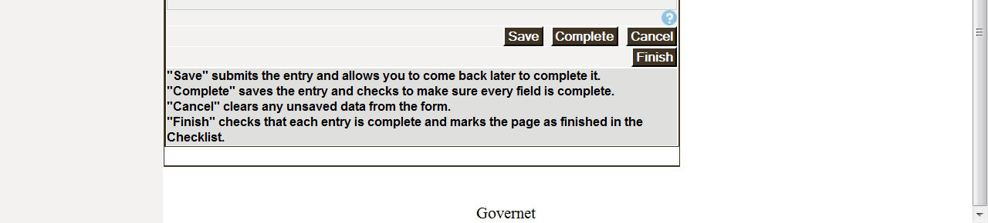
You can only select “Finish” when you have created a form, input the data and marked complete for each student learning outcome.

Select Course Summary from the right column. Complete one form for the course.
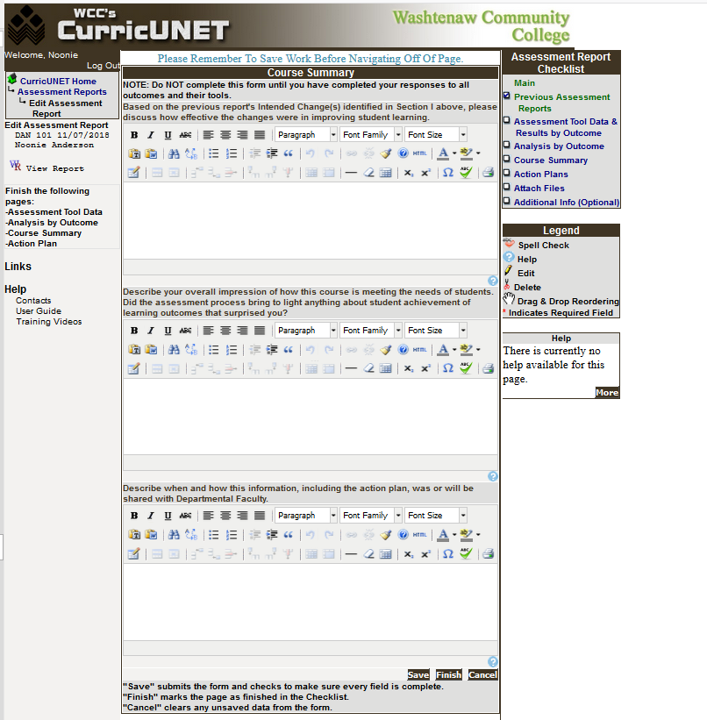
If this course was previously assessed, please respond to the first question: Based on the previous report's Intended Change(s) identified in Section I above, please discuss how effective the changes were in improving student learning. If the course had not previously been assessed you may leave this field blank or write N/A.
Continue with responses to the other two questions. Once those fields are populated, you can click “Finish”.

Select Action Plans from the Assessment Report Checklist
Are changes needed – No. Click the radial button for No and click Finish.
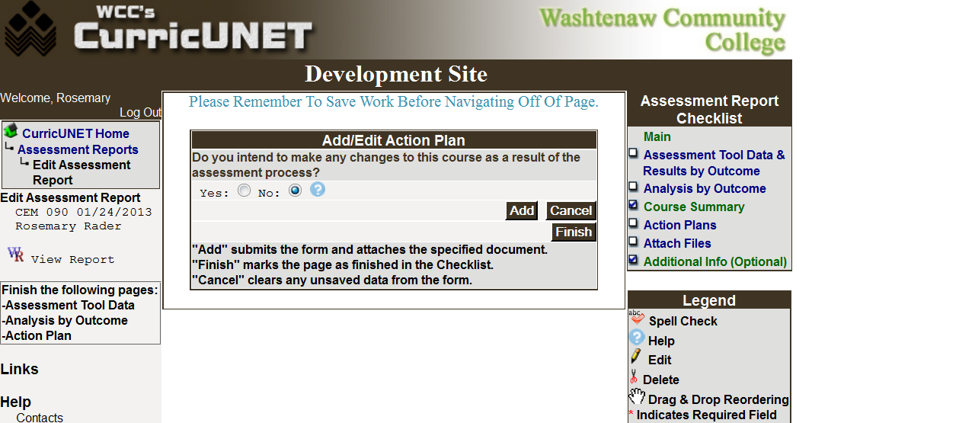
Are changes needed – Yes. Click the radial button for Yes. Use the dropdown box to select from the possible intended changes options.
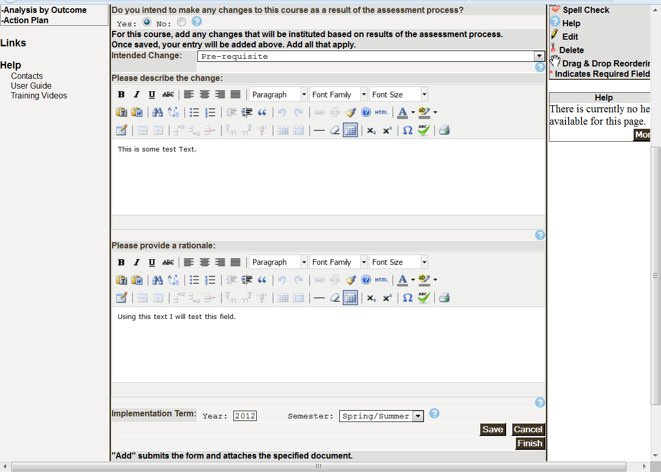
Attaching required materials
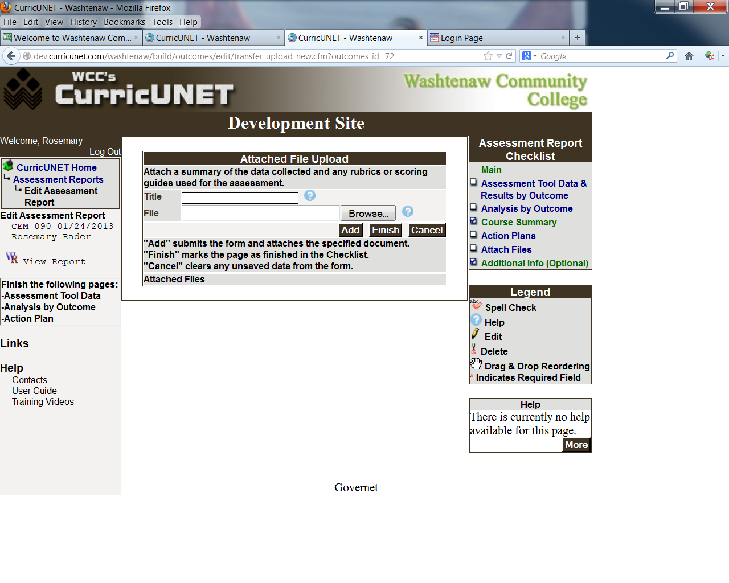
The following materials are required:
- Sample questions 2-4 of each type (multiple-choice, TF, Essay, etc.) from each test or exam. [Note: these will not be available to students]
- Rubrics or checklists used to assess an outcome.
- Summary of anonymous assessment results, submitted in a format that aligns with the standard of success. Please do not submit student names or student numbers.
Note: Please use a meaningful name that includes the course subject and number.

Getting in the last word
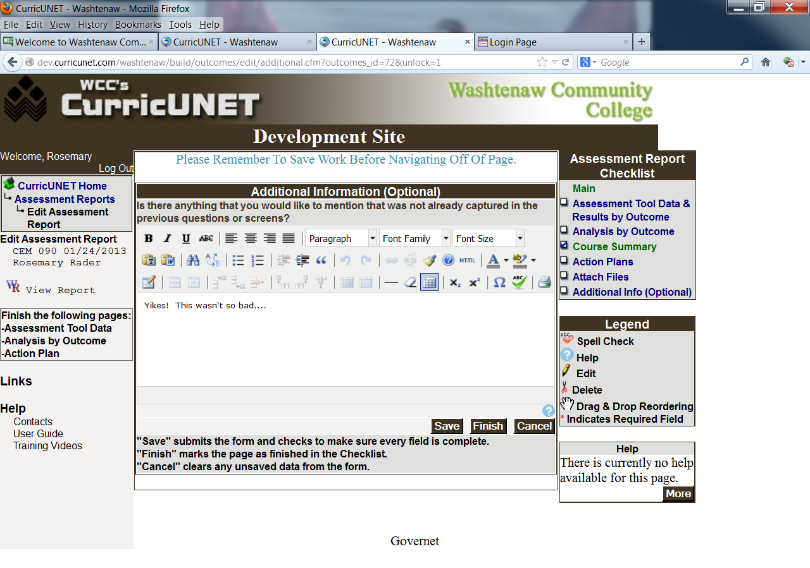

Once you have finished with the assessment report, click on the SUBMIT button that will appear in the left column. The report will move through the workflow to department chair, dean and the Office of Curriculum and Assessment prior to being presented to the Assessment Committee.
Once the Assessment Committee has reviewed the assessment report, you will receive an e-mail from the Office of Curriculum & Assessment, which will include the committee’s comments and any suggestions for future reports.
After review by the Committee, the assessment report will be processed and a copy of the report will be stored on the Curriculum and Assessment Office Web page.

