Washtenaw Community College
CHANGE or REVIEW COURSES
CurricUNET Training
September 2016

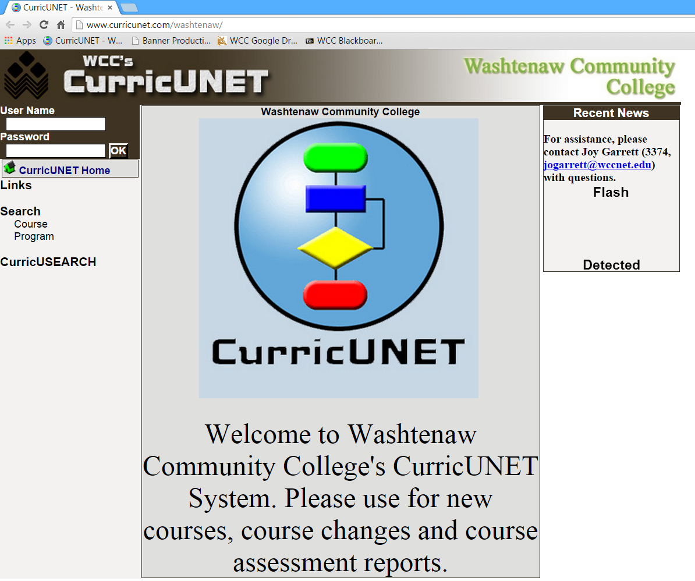
Welcome to Washtenaw Community College’s CurricUNET system. In this document, we will explain how the system will be used to revise a master syllabus.
Sign on to CurricUNET.
- Open a web browser.
- Type www.curricunet.com/washtenaw to bring up the WCC CurricUNET homepage.
- Type in your User Name (same as your WCC net id) and Password.
- Click OK



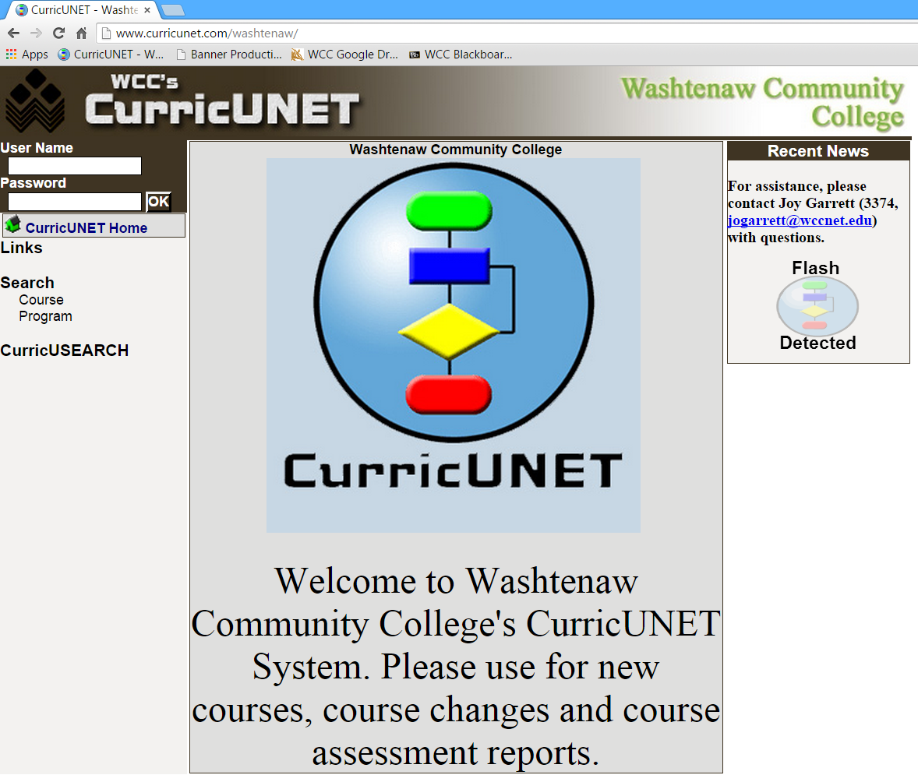

Main Menu Bar
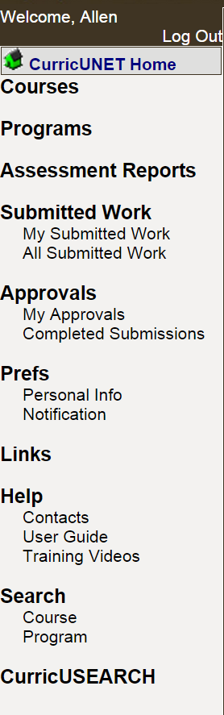 | Log Out – Logs you out of CurricUNET.  CurricUNET Home – The CurricUNET Home button takes you to the Home Page, main menu, of CurricUNET. This page provides an entry point into the system.  Courses – You may build a new course, update an existing course or inactive a course.  Programs – This is a future feature to be implemented at a later date.  Assessment Reports – Create or edit an assessment report.  Submitted Work – You may see your submitted work or college-wide submitted work.  Approvals – Area where you can track your approvals and proposals.  Prefs – Edit your personal information.  Help – The Help area contains important contact information and the CurricUNET User Guide and training videos.  Search – The Search area is where all WCC course searches are conducted.  The CurricUSEARCH area allows you to search for course outlines at other nationwide campuses that utilize CurricUNET.
Explanation of Symbols
Legend
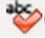
Spell Check
Help
Copy
Edit
Delete
Move Item Up
Move Item Down
* Indicates Required Field
Course Impact Report
Course Outline Report
Course Changes Report
Course Syllabus
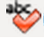
Spell Check – Located in most boxes requiring you to enter information, click this symbol in the body of the screen to initiate spell checking.
Help – Click this symbol to read additional information about the section or task being completed.
Edit – Click this symbol to edit the listed item.
Delete – Click this symbol to delete the listed item. The system will ask you to confirm that you want to delete the item. If you confirm, it is permanently deleted and cannot be retrieved.
Move Item Up
Move Item Down – Use these arrows to move an item up or down in a listing.
* Indicates Required Field – You will not be able to save your data or move on to the next area unless you fill in all required fields.
Copy – Click this symbol to copy the listed item and begin to edit the course. A new version of the master syllabus is created for your use.
Course Outline Report – Click this symbol to view the CurricUNET version of the WCC Master Syllabus.
Course Changes Report – Click this symbol to view the Course Changes Report.
Course Impact Report – Click this symbol to view the Course Impact Report.
Course Syllabus – Click this symbol to view the Course Syllabus.
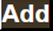
Add – Adds an item and allows to to add a second item without close the current screen.
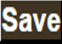 Save – Saves your work without closing the current screen.
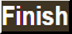 Finish – Closes the current screen and completes the current section.
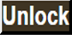 Unlock – Allows you to edit the previously finished/saved section.
Inactivate a Current Course
It is important to understand that the College must maintain a historical record of courses and programs. Therefore, any time you want to update/revise or inactivate a course, a copy of the course must be made in CurricUNET.
- Click on Courses from the main menu to access the Course Submenu.
- Select Inactivate Course from the Course Submenu. Below are the actions that you may perform in the Course Submenu:
- Build New Course (see New Course Submission Training Manual)
- Update Existing Course – this includes a 3-year review or course change
- Inactivate Course – Change a course that is not currently in use to an inactive status. Courses can be reactivated using a process similar to update existing course.

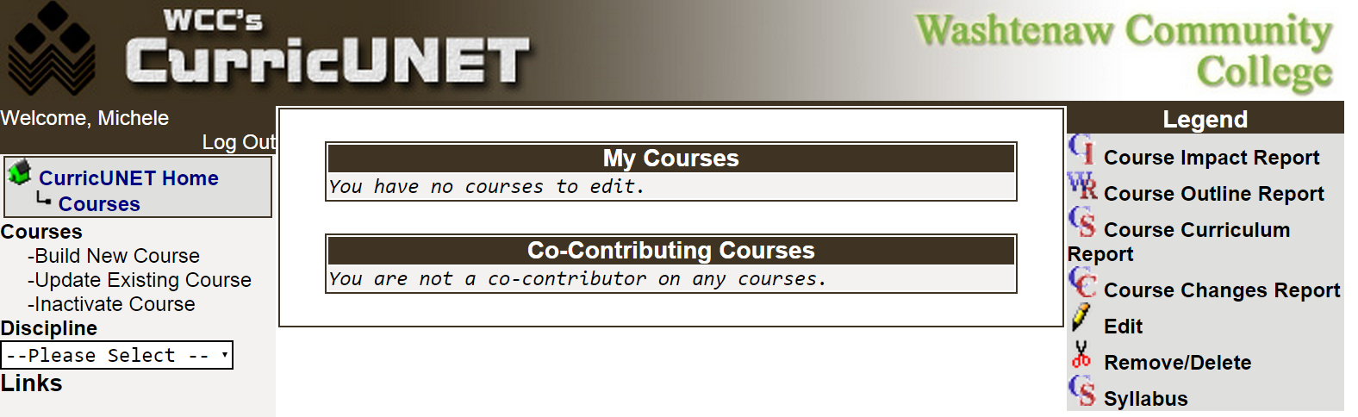

- Select the appropriate Discipline from the dropdown boxes.
- Once the discipline has been selected, click OK.
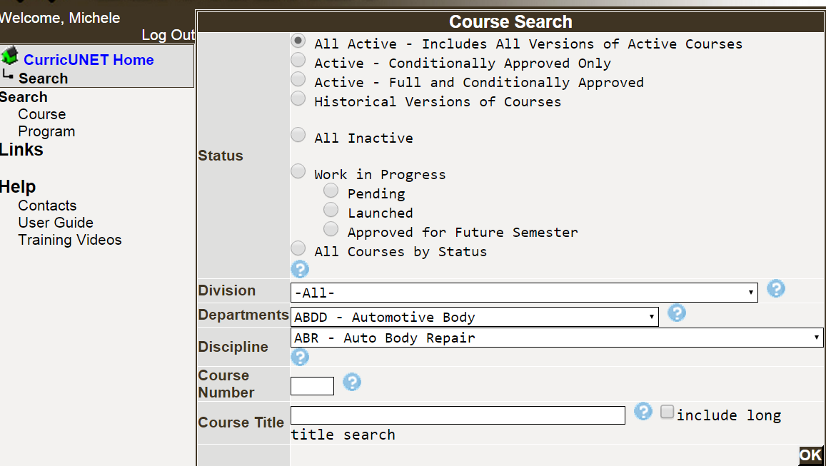

Copy the Course to be Inactivated

- Copy the Course you wish to inactive by clicking on the Copy icon.

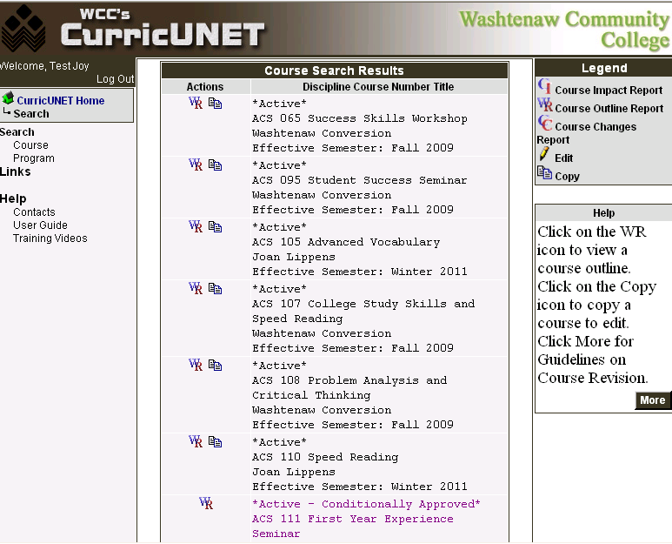

NOTE: There are two reasons why the Copy symbol will not appear next to a course.
  - If you do not have access to that discipline, the copy function will not appear.
  - If the course revision has been initiated by another user, the copy function will not appear.
EXAMPLE: ACS 111 does not have a copy icon next to it. That course has been copied and a faculty member is already in the process of updating that course.

- Select Course Inactivation for the Proposal Type from the dropdown box.
- Leave the Change Information with the default information. These values will be updated by the Office of Curriculum and Assessment.
- Click Next.

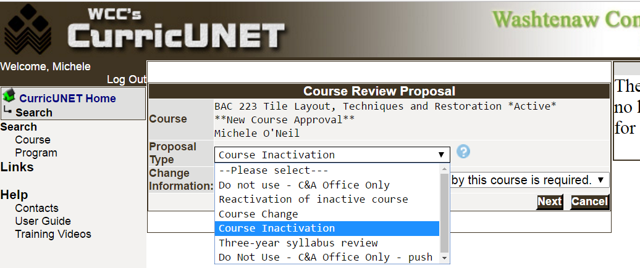

- Explain the Rationale behind why the course is being inactivated. Spell check is available by clicking
the Spell Check icon.
- Click OK.

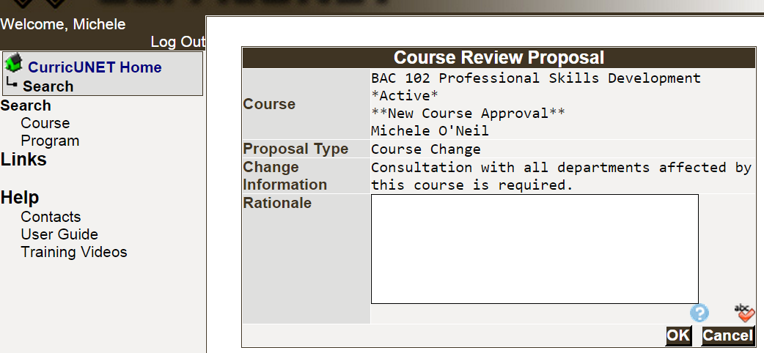

- Because the system is now copying the complete course, you may experience a brief delay. Do not panic.

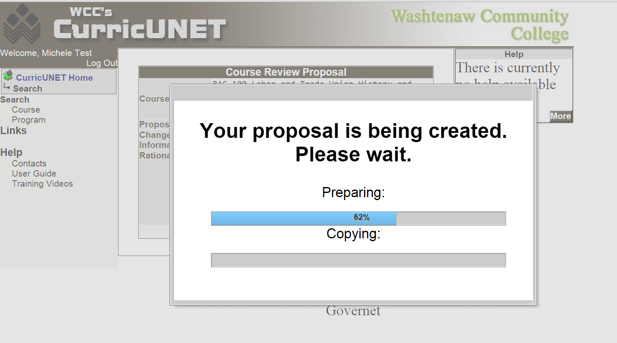

  - If the copy were to fail, you will receive an error message.
  - Once the course has been successfully copied, the next screen to appear is the Course Construction Main Menu.

Course Construction Main Menu

Course Checklist

Begin the Course Cover by clicking on the Course Cover link in the Course Checklist. Hint: Do not click on the checkbox next to the link.

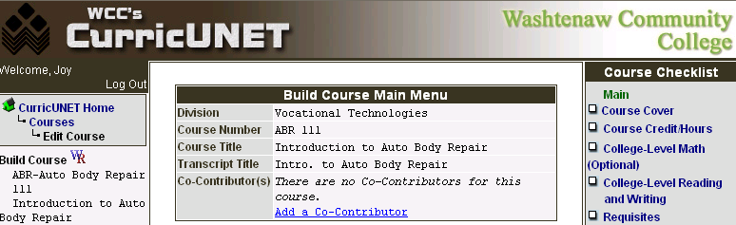
Edit Course Cover Information

All information currently stored in the database will appear. NOTE: The Curriculum and Assessment Office will input the Reason for Submission and Change Information.
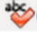
- Make sure that the Rationale is correct. Include any impacts to an existing program(s) if appropriate. Click on the Spell Check icon to initiate the spell checker.
- Select the Proposed Start Semester from the drop down and type the proposed start Year.
- Save before you navigate from this page. When you are satisfied with the information on this page, you should click Finish. This will result is a check appearing next to Course Cover in the Course Checklist.

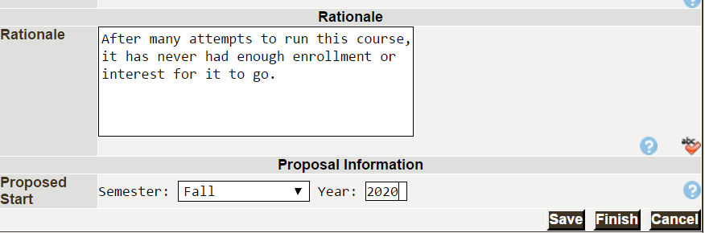

Submit Course into Workflow
Once you have “Finished” the Course Checklist, you will see a You may Submit your course now message with the Submit button.
It is important to note that the Submit button appears after you have completed the required sections in the Course Checklist. For a course inactivation, it is the Course Cover.
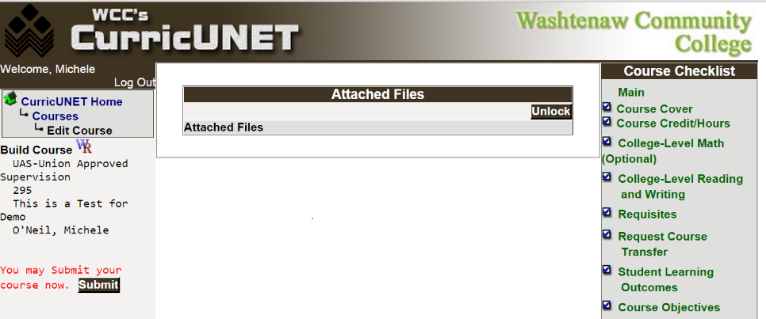
When you click the Submit button, the system will perform an audit and respond with the screen below:
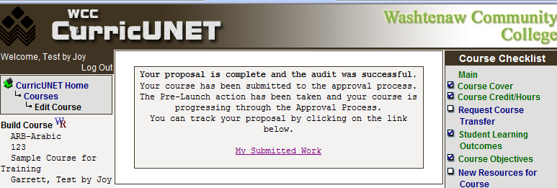
Check the Status of Your Submission
When the course is submitted, the department chair will be notified via e-mail that there is an approval that requires his/her attention and the approval/review process will begin.

Click on the My Submitted Work link on the Main Menu and then click Check Status to see the status of the course in the approval/review process.
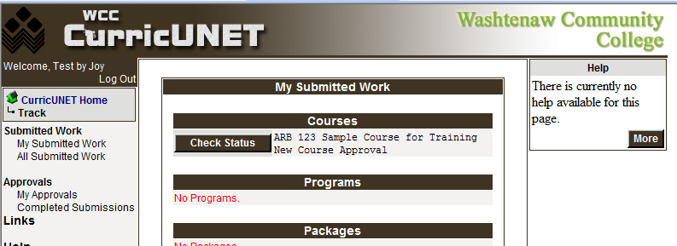

Below is a sample of a course submitted for approval/review and is waiting for the department chair to review and approve it.
