Washtenaw Community College
NEW COURSE SUBMISSION
CurricUNET Training
Revised July, 2015

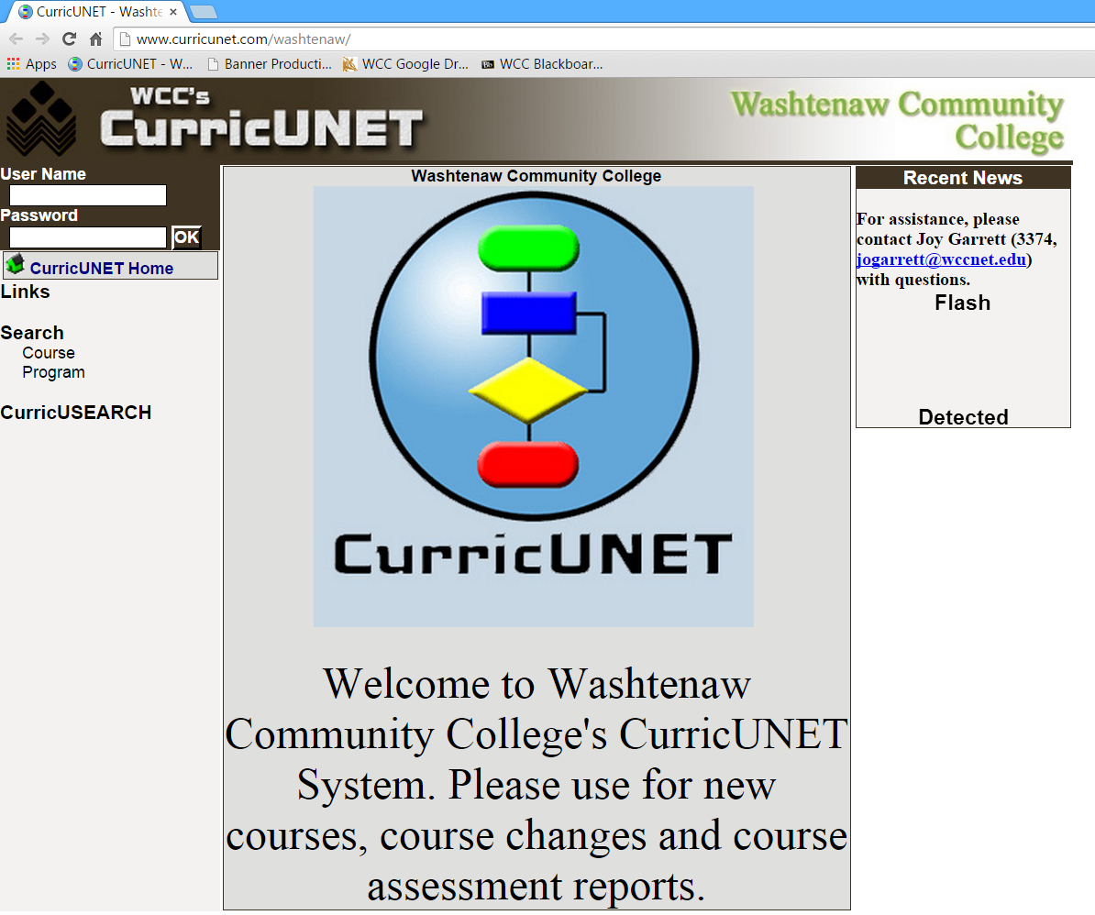
Welcome to Washtenaw Community College’s CurricUNET system. In this document, we will explain how the system will be used to submit a master syllabus.
Sign on to CurricUNET.
- Open a web browser.
- Type www.curricunet.com/washtenaw to bring up the WCC CurricUNET homepage.
- Enter your User Name (same as your WCC net id) and Password.
- Click OK.



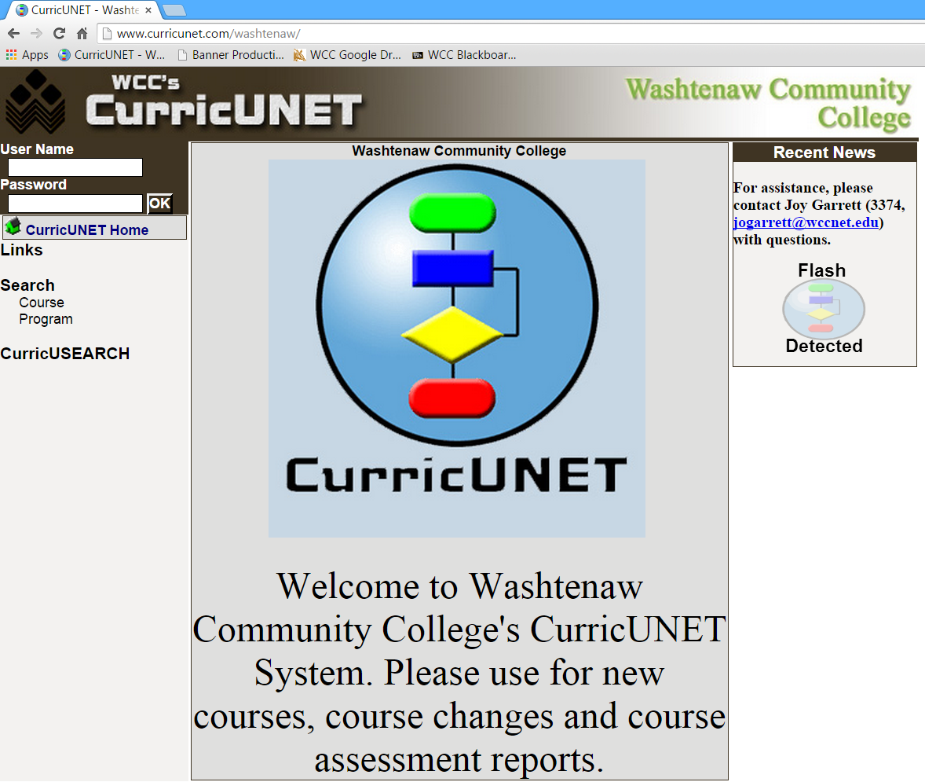

Main Menu Bar
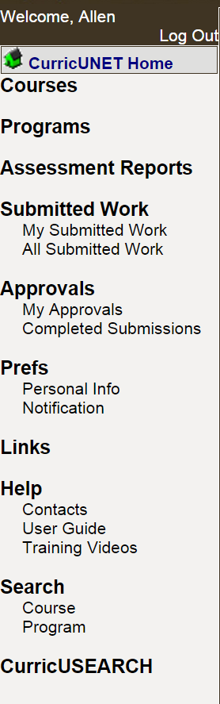 | Log Out – Logs you out of CurricUNet.  CurricUNET Home – The CurricUNET Home button takes you to the Home Page, main menu, of CurricUNET. This page provides an entry point into the system.  Courses – You may build a new course, update an existing course or inactive a course.  Programs – This is a future feature to be implemented at a later date.  Assessment Reports – Create or edit an assessment report.  Submitted Work – You may see your submitted work or college-wide submitted work.  Approvals – Area where you can track your approvals and proposals.  Prefs – Edit your personal information.  Help – The Help area contains important contact information and the CurricUNET User Guide and training videos.  Search – The Search area is where all WCC course searches are conducted.  The CurricUSEARCH area allows you to search for course outlines at other nationwide campuses that utilize CurricUNET.
Explanation of Symbols
Legend
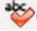
Spell Check
Help
Copy
Edit
Delete
Move Item Up
Move Item Down
* Indicates Required Field
Course Impact Report
Course Outline Report
Course Changes Report
Course Syllabus
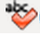
Spell Check – Located in most boxes requiring you to enter information, click this symbol in the body of the screen to initiate spell checking.
Help – Click this symbol to read additional information about the section or task being completed.
Edit – Click this symbol to edit the listed item.
Delete – Click this symbol to delete the listed item. The system will ask you to confirm that you want to delete the item. If you confirm, it is permanently deleted and cannot be retrieved.
Move Item Up
Move Item Down – Use these arrows to move an item up or down in a listing.
* Indicates Required Field – You will not be able to save your data or move on to the next section unless you fill in all required fields.
Copy – Click this symbol to copy the listed item and begin to edit the course. A new version of the master syllabus is created for your use.
Course Outline Report – Click this symbol to view the CurricUNET version of the WCC Master Syllabus.
Course Changes Report – Click this symbol to view the Course Changes Report.
Course Impact Report – Click this symbol to view the Course Impact Report.
Course Syllabus – Click this symbol to view the Course Syllabus.
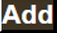
Add – Adds an item and allows to to add a second item without close the current screen.
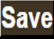 Save – Saves your work without closing the current screen.
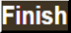 Finish – Closes the current screen and completes the current section.
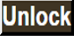 Unlock – Allows you to edit the previously finished/saved section.
Build a New Course
Click on Courses from the Main Menu on the left-hand side of the screen.
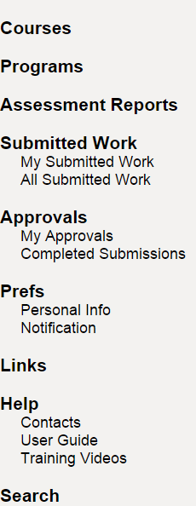
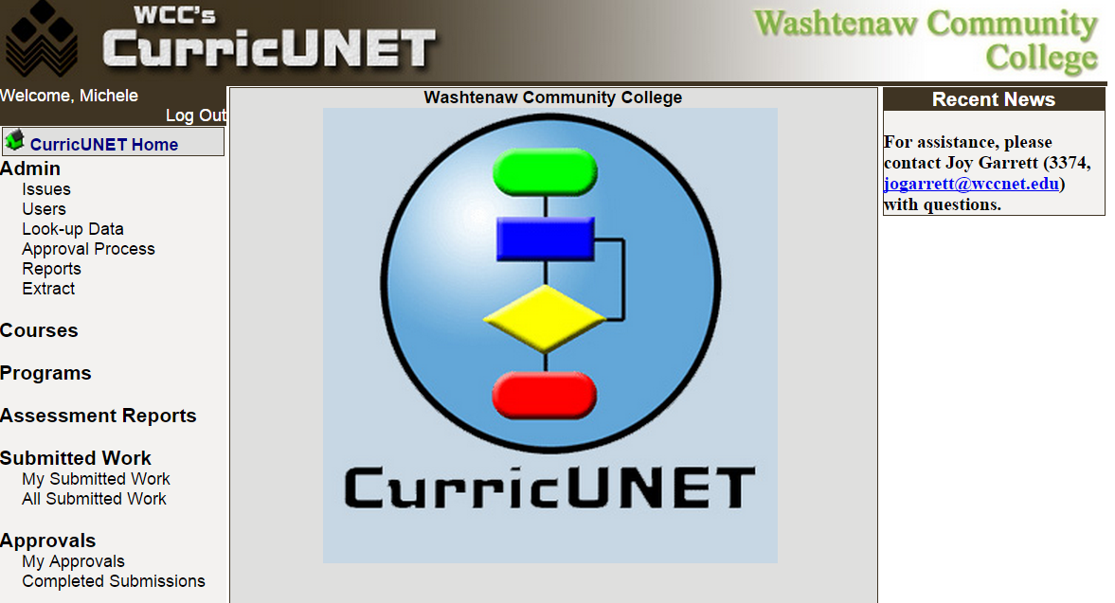
The Courses screen will show menu options related to your courses and any courses you have built or are the co-contributor for. The menu options for courses are Build New Course, Update Existing Course or Inactivate Course. For this tutorial, we are building a new course. To build a new course, click on the Build New Course Link.

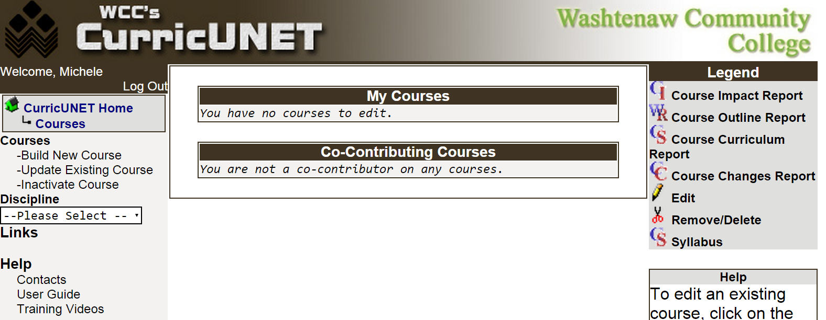
Create New Course

Your first step is to complete the Create New Course screen.
- Select Discipline from the dropdown box. You will see only the discipline codes for which you are authorized. If your discipline is missing, please contact the Director of Curriculum and Assessment (jogarrett@wccnet.edu or 973.3374).
- Enter the Course Number. If you attempt to reuse a course number, an error message will appear. If you need assistance in identifying an available course number, please contact the Curriculum Analyst (mioneil@wccnet.edu or 477.8510).
- Input the Course Title. Title must be 30 characters or less to default to the transcript title. If the title is more than 30 characters, you must also input a 30-character Transcript Title.
- Input the Catalog Description. Use the Spell Check button to initiate the spell checker.
- The Proposal Type will default to New Course Approval and does not need to be changed.
- When satisfied, click the OK button.



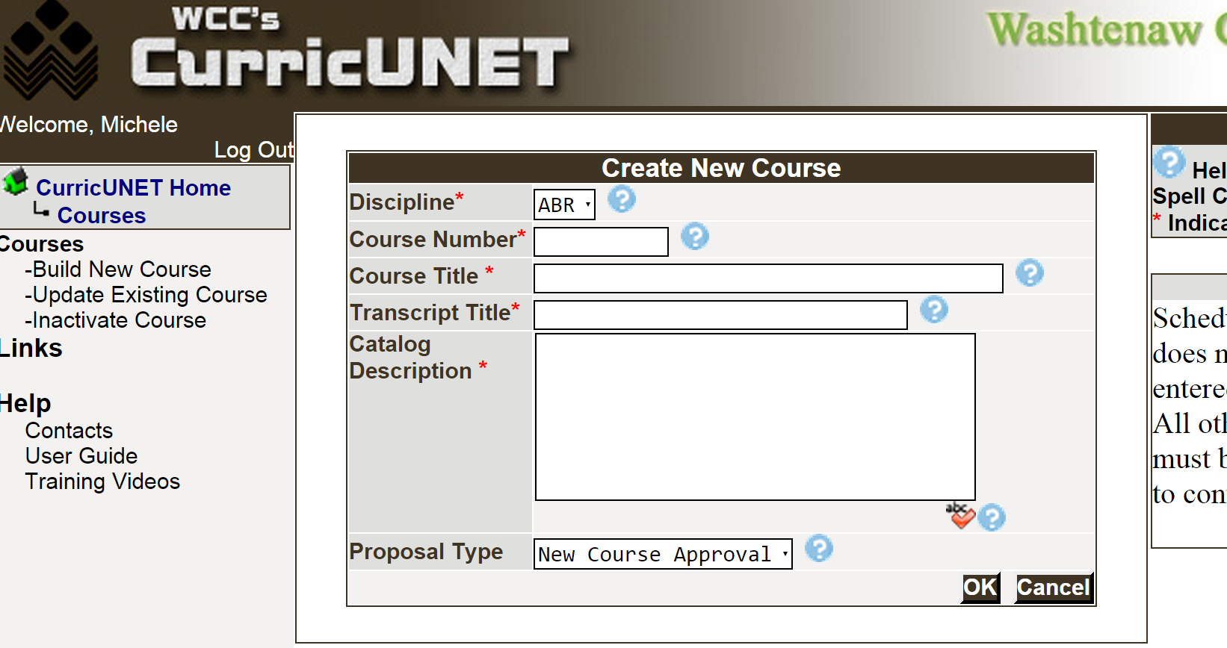

The next screen to appear will be the Build Course Main Menu.

Build Course Main Menu
On the Build Course Main Menu, you can add a co-contributor. This would be an individual that you want to have update access to the new course you are building. You will click on the Add a Co-Contributor link, and it will prompt you to select a user name and identify the screens/sections that the individual will be allowed to update. You are not required to add a co-contributor.
Course Checklist
Use the Course Checklist on the right side of the Build Course Main Menu to select the next action you wish to take. It is your navigation through the build a new course process. You are encouraged to follow this checklist in order. You can return to any section by clicking the specific link in the Course Checklist.
The following sections in the course checklist are required in order to “submit” your new course: Course Cover, Course Credit/Hours, College-Level Reading and Writing, Student Learning Outcomes and Course Objectives.
Begin the Course Cover by clicking on the Course Cover link in the Course Checklist. Hint: Do not click on the checkbox next to the link.
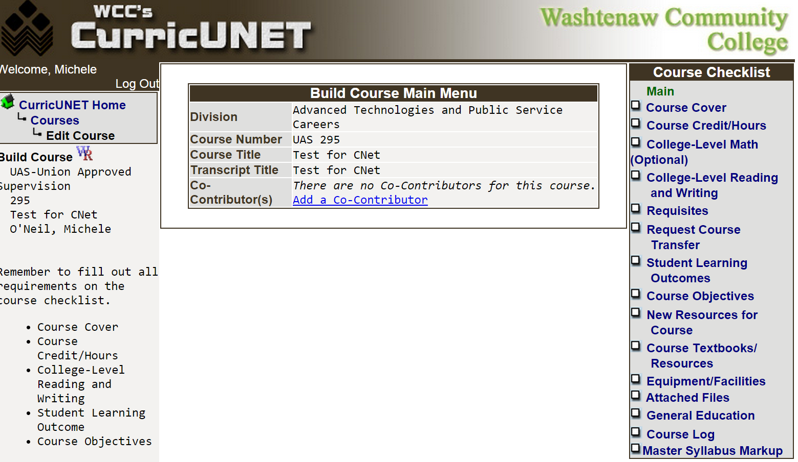

Enter Course Cover Information (Required)
The division, department, discipline, course number, full course title, transcript title and catalog/course description fields will appear in the Course Cover section of the Course Checklist.
- Input Org. # (Banner Org number). Contact your department chair or dean with questions. If needed, you may edit the Full Course Title or the Transcript Title.
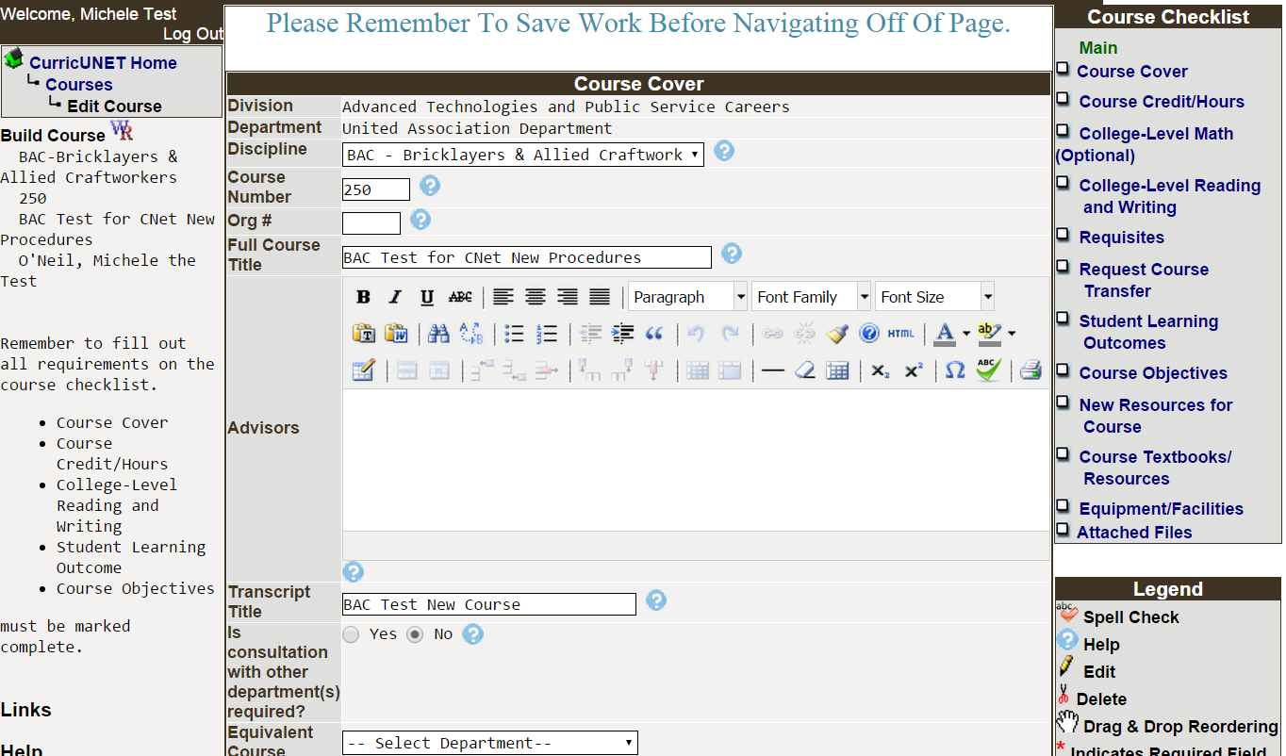
- Check the appropriate boxes in the Publish in the Following area to indicate whether the course should be published in the catalog, time schedule or on the web page. In most cases all three boxes should be checked. At this time, you may also make any changes to the Course Description if needed.
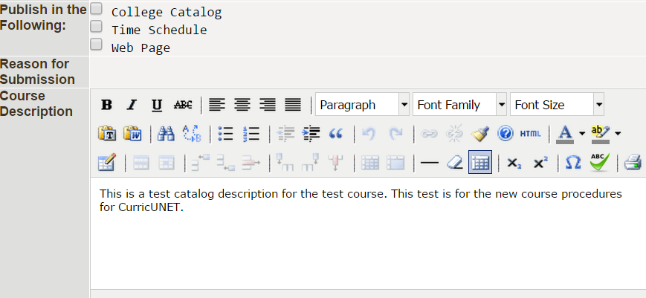
- Indicate the Rationale for the new course. Include how the course will fit into an existing program(s) if appropriate. Click on the Spell Check icon to initiate the spell checker.
- Select the Proposed Start Semester from the drop down and type the proposed start Year.

- Save before you navigate from this page. 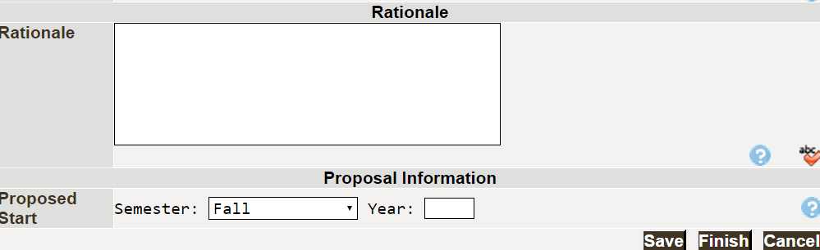
- When you are satisfied with the information on this page, click Finish.
This will result is a check appearing next to Course Cover. Prior to launching the course, you will be able to Unlock the page to make additional changes or corrections.
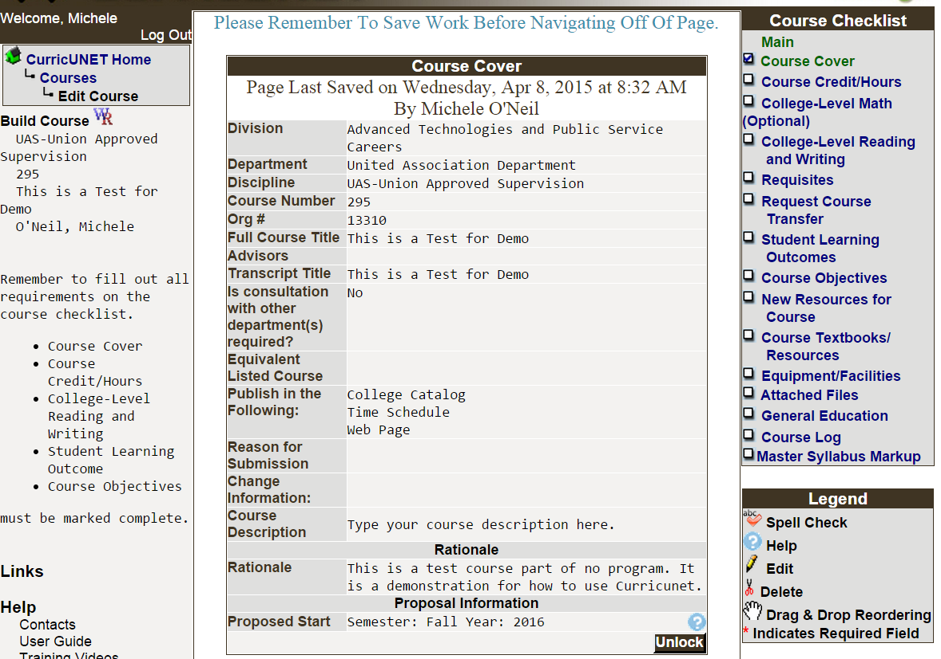

Input Course Credit/Hours (Required)
The next step in the process is to input the credit and contact hours, the repeat option and the grading option for the course. Click on the Course Credit/Hours link in the Course Checklist.
- Your course is either going to be offered with variable or non-variable credit/hours. The most common is standard/non-variable and is explained below. If your course can offered for variable credit, skip to the Variable Credit/Hour explanation on the next page.
Standard, Non-Variable Credit/Hours Only
For standard (not variable) credit hours, the default is No for Variable Hours.
- Type the credit hours in Credits.
- Type the Lecture Hours in both the Instructor and Student boxes. Generally, 1 credit hour = 15 contact hours of lecture.
- Enter Lab Hours if used for both the Instructor and Student boxes. Generally, 1 credit hour = 30 or 45 contact hours of lab).
- Input Clinical hours if used for both the Instructor and Student boxes.
- Input Describe Other Contact Hours for both the Instructor and Student boxes if the hours do not fall under one of the categories above. A textbox will appear for you to explain the hours.






- The Total Contact Hours will be calculated by the system. To adjust the total hours, you must change a value in either Lecture, Lab, Clinical or Other.
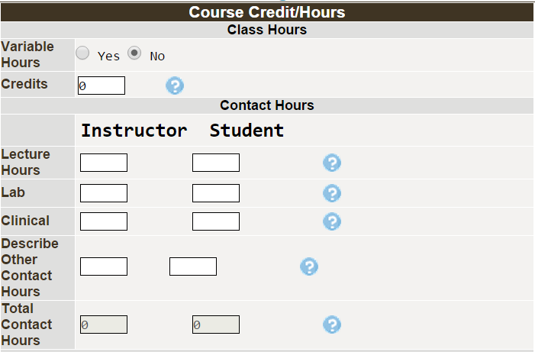

Variable Credit/Hour Only Sample

These steps are for building a course that can be offered with variable credits/hours. If this does not apply to your course, proceed to the next step.

In the variable credit/hour example below, students may earn up to 3 credits depending on how many lecture and lab hours they enroll in.
- For variable credit hours, click Yes for Variable Hours.
- Type the minimum and maximum credit hours in Credits.
- Type the minimum and maximum Lecture Hours in both the Instructor and Student boxes. Generally, 1 credit hour = 15 contact hours of lecture.
- Enter the minimum and maximum Lab Hours if used for both the Instructor and Student boxes. Generally, 1 credit hour = 30 or 45 contact hours of lab).
- Input the minimum and maximum Clinical hours if used for both the Instructor and Student boxes.
- Input the minimum and maximum Describe Other Contact Hours for both the Instructor and Student boxes if the hours do not fall under one of the categories above.
- The Total Contact Hours will be calculated by the system. To adjust the total hours, you must change a value in either Lecture, Lab, Clinical or Other.

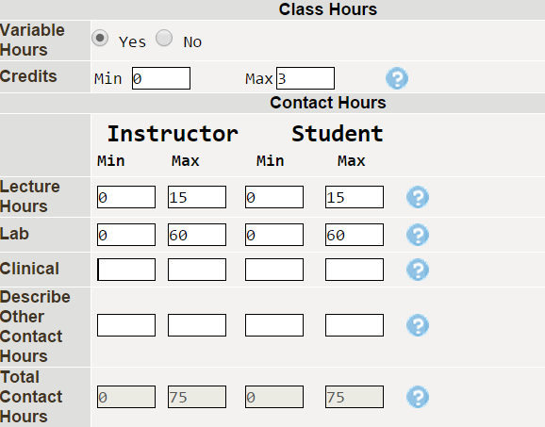

- If a course can be repeated for credit, click Yes for Repeatable for Credit. A box will appear in which to record the number of times the course can be repeated for credit.
The system will default to NO. A course that can be repeated for credit does not allow students the opportunity to repeat a course for a better grade.
- Check the appropriate Grading Method. Most courses 100 or above are taught for a letter grade.
- Indicate if the lecture and lab are taught in separate sections. The system will default to NO.
- Click on Save before you navigate from this page.
- When you are satisfied with the information on this page, click Finish.

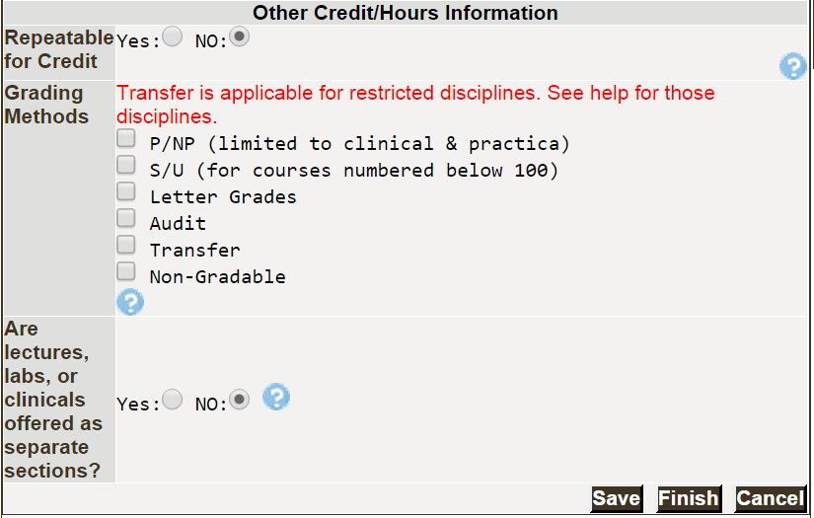

Finishing will result in a check appearing next to Course Credit/Hours in the Course Checklist. Prior to launching the course, you will be able to “unlock” the page to make additional changes.
College-Level Math (Optional)

For courses that have a math level requirement, you may enter those in the College-Level Math (Optional) section. The Math Department’s web site has a description of math placement scores and courses; you may access it at http://departments.wccnet.edu/math/.
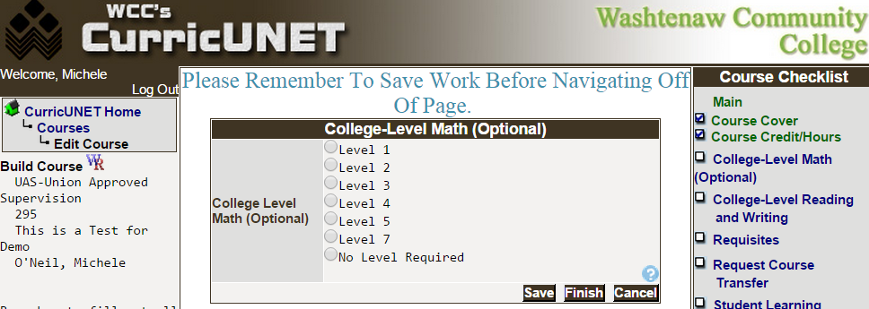
Be sure to click on Save before you navigate from this page. When you are satisfied with the information on this page, click Finish.
College-Level Reading and Writing (Required)

In this section, you will indicate what level for reading and writing is required for your course. Click on the College-Level Reading and Writing link in the Course Checklist.
- Select the appropriate reading and writing levels. If the level that applies to your course is Reduced Reading/Writing Scores, you will enter those scores in the Requisites section.
- Click Save before you navigate from this page. When you are satisfied with the information on this page, click Finish.
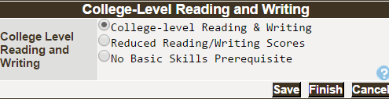
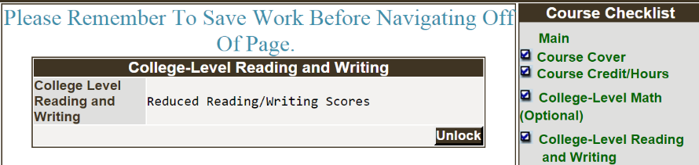
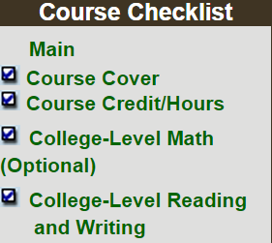
This will result is a check appearing next to College-Level Reading and Writing in the Course Checklist. Prior to launching the course, you will be able to Unlock the page to make additional changes.

Requisites
Types of Requisites to add to your course include the following:

- Prerequisite: Prerequisites include classes, tests or programs that the student must successfully complete prior to enrolling in this course. If your course has reduced reading and/or writing levels, you will enter those levels in this option.
- Level II Prerequisite: These are recommended classes, skills, tests or programs that a student should have prior to enrolling in this course. The registration system cannot verify that the student meets recommendations.
- Corequisite: Identifies courses that must be taken at the same time. Students are not permitted to register for only one of the two or more courses.
- Enrollment Restriction: May be used to identify restrictions such as admission to a program or instructor permission required.

- Click on the Requisites link in the Course Checklist if needed.
- Select the Requisite Type from the dropdown menu.
- Click Add.
- When you are satisfied with the information on this page, click Finish.
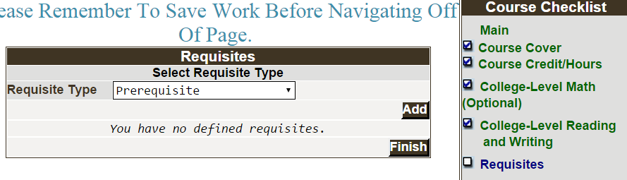
The following is an example of adding a prerequisite.

Sample – Adding a Prerequisite

- Select Prerequisite as the Requisite Type from the Requisites menu and click on Add if you have not already done so.
- If the prerequisite is a WCC course, select the course from the Course # and Title dropdown box.
- Input a minimum grade in Min Grade if the student must earn a grade higher than the default of D-.
- Check the Concurrent Enrollment box if the student may take the prerequisite at the same time.
- Describe the prerequisite if it is not a WCC course in the Comment or Non Course requirement textbox. If your course has reduced reading and/or writing levels, those levels get entered in this textbox.
- If more than one prerequisite will be required, select the Condition, and or. If you use the “and” condition the next course added will also be required. For example, ENG 111 and ENG 226.
- When completed, click Add.
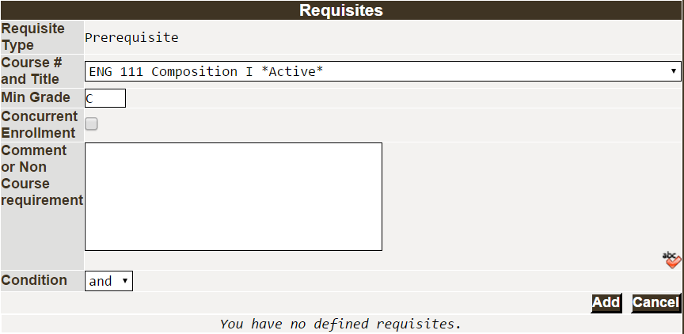
- You may add an additional Requisite at this point by selecting the Requisite Type and clicking Add.
- If you make a mistake, you may edit or delete the Requisite with the editing options.

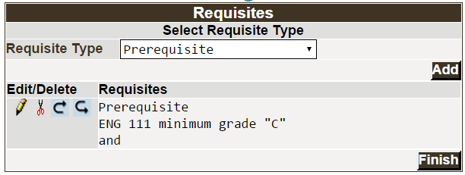
- Click Finish. This will result in a check appearing next to Requisites in the Course Checklist. You will be able to Unlock the page to make additional changes prior to launching the course.

Request Course Transfer Equivalency Review (Optional)

For new courses or a course with a significant change to the content, please select schools where the course might transfer.

- Click on the Request Course Transfer link in the Course Checklist if needed to complete the Request Course Transfer section.
- Select the Proposed For schools where the course might transfer.
- Select Other to identify and enter a specific course transfer and/or school not listed.
- Click on Save before you navigate from this page.
- When you are satisfied with the information on this page, click Finish.
This will result in a check appearing next to Request Course Transfer in the Course Checklist. You will be able to Unlock the page to make additional changes prior to launching the course.

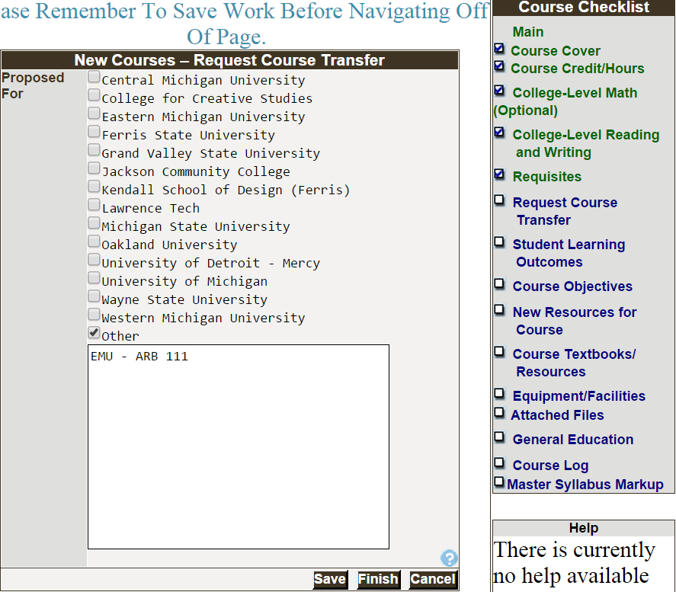
Add Student Learning Outcomes (Required)
- Enter the learning outcomes for your course by clicking on the Student Learning Outcomes link in the Course Checklist. A description of outcome language, tools and scoring methods can be found by clicking on Taxonomy. The Taxonomy document will open in a new window.
- Each outcome is added separately, one at a time. Type the learning outcome, using measurable language, in the Outcome Text textbox. Spell check is available by clicking the Spell Check icon.
- Click Add. Your student learning outcome is added and the Outcome Text textbook appears for you to enter the next outcome. A summary of the Outcomes will appear at the top of the page.
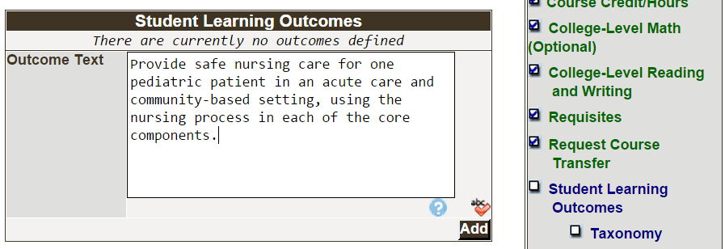
- Repeat this process until all of your outcomes have been entered. You will add assessment plan/data in the next section.
- Note: if you try to click Finish before entering an Assessment Plan, you will receive an error messsage.

Add Assessment Plan Details for Each Outcome (Required)
- Click on the Student Learning Outcomes link in the Course Checklist if necessary to access the Assessment Plan.
Note that you can change the order of the outcomes, edit an outcome or delete it by clicking on the appropriate edit icons.
- Click on the Add/Edit Assessment Plan link below the first Student Learning Outcome.
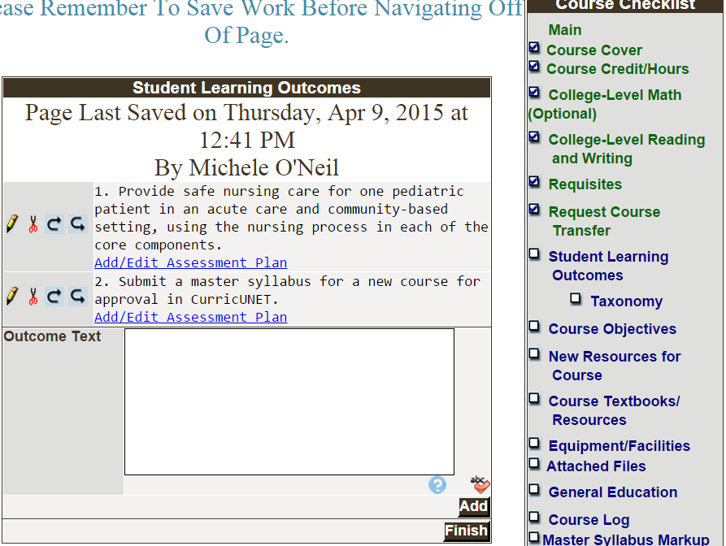

    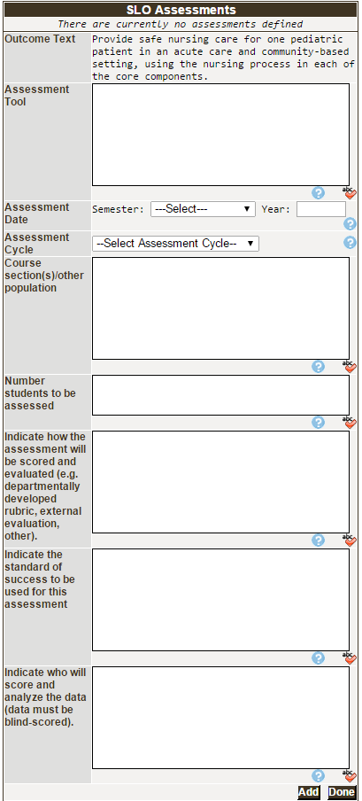 | Remember to use Spell Check as needed when typing in the textboxes. The Outcome Text appears above the Assessment Tool.  - Enter the Assessment Tool that will be used to assess the outcome (e.g., test, written essay, performance, etc.).  - Indicate the Assessment Date (Semester and Year) when you plan to assess the course.  - Select the Assessment Cycle from the dropdown box.  - Identify the Course section(s) or other population you will select to assess.  - Indicate the Number of students to be assessed.  - Indicate how the assessment will be scored and evaluated (e.g. departmentally-developed rubric, external evaluation, other).  - Indicate the standard of success to be used for this assessment.  - Indicate who will score and analyze the data (data must be blind-scored whenever possible).  - When you are satisfied with the information on this page, click Add.

- Assessment Plan:
  - The Assessment Tool that was entered will appear under the Outcome Text.
  - To see the details of that Assessment Plan, click on the Edit icon and the boxes will be populated.
  - To copy the Assessment Plan to another outcome, select the copy icon.
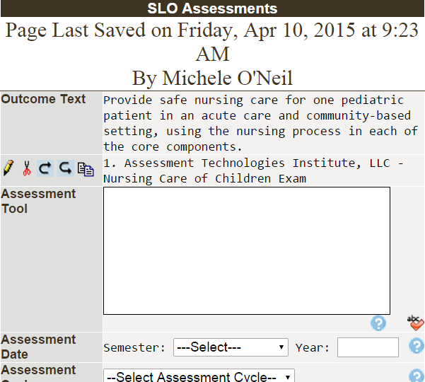
- Add another assessment tool if needed to the appropriate Student Learning Outcome. When all assessment tools have been added for an outcome, click Done. You will return to the Student Learning Outcomes page.
- When you have updated all outcomes and the associated assessment information, click Finish. This will result in a check appearing next to Student Learning Outcomes. You will be able to Unlock the page to make additional changes prior to launching the course.

Copy Assessment Plan to Another Outcome

An enhancement to the CurricUNET system allows faculty to copy an assessment plan from one outcome to another. This feature will save significant input time when the plans are substantially the same.

- Click on the Add/Edit Assessment Plan link in Student Learning Outcomes section if necessary.
- Click the Copy icon on the SLO Assessments screen.
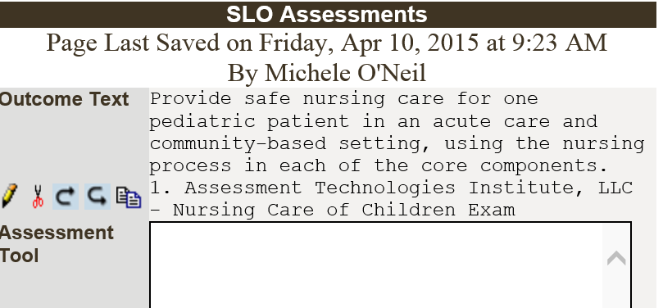
- Select the Student Learning Outcome which you want to copy the assessment plan to on the Copy To dropdown menu.
- Click Save.
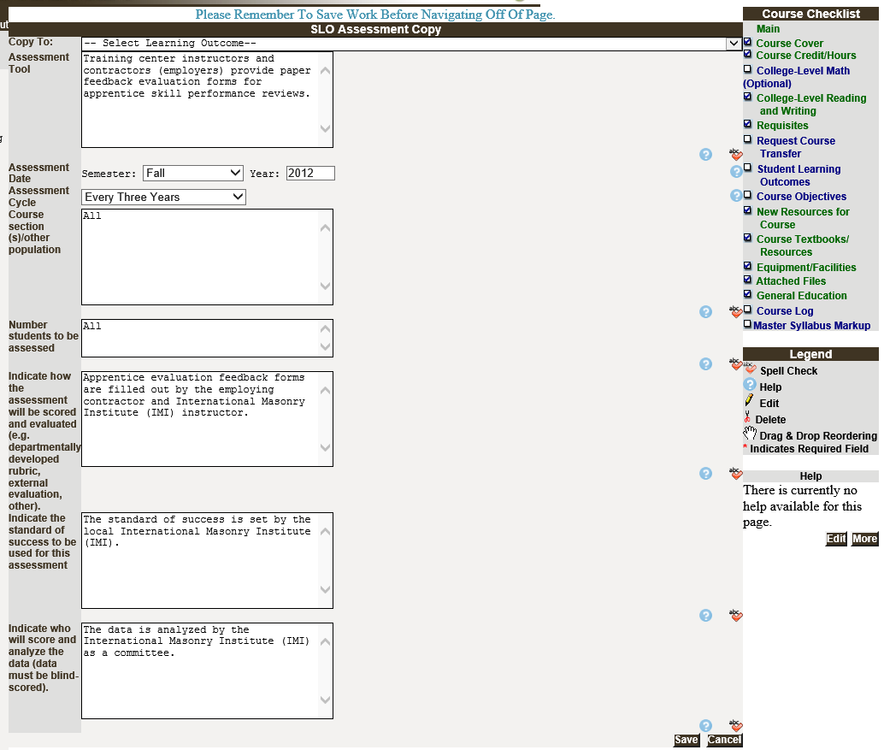
- You will return to the original SLO Assessments screen, which will display the original outcome and the original assessment plan (not the one that you copied to). You may copy the assessment plan to another outcome and repeat the process until completed.
- Click Done when finished and you will return to the Student Learning Outcomes page. A check will appear when you have added an Assessment Plan for each outcome.
Course Objectives (Required)

Course Objectives are added one at a time. Click the Course Objectives link if necessary to access.

- Type the first objective using measurable language in the Objective Text box. Use the Spell Check icon to check spelling.
- Click the Add button.
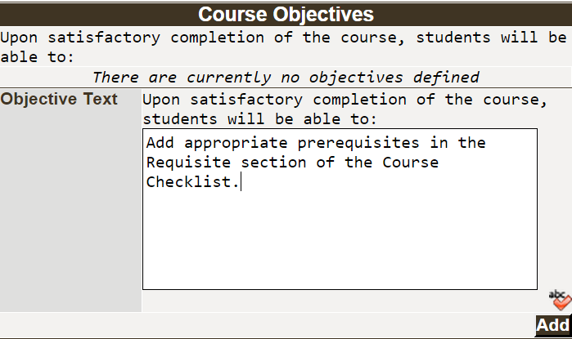
- Repeat the process of adding each course objective individually. You may edit the Course Objectives by using the Edit icons.
It is important to note that we are NO longer matching course objective to outcomes.
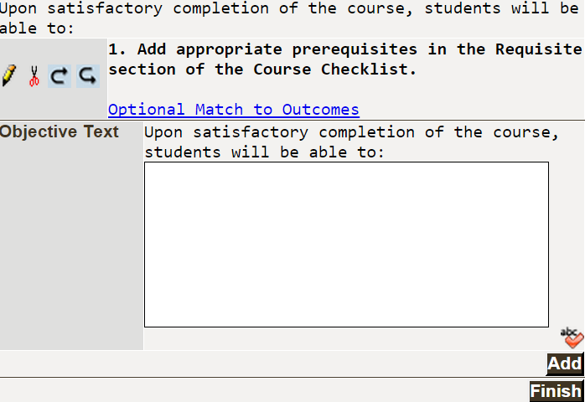

- When you have finished adding all of your course objectives, click Finish. A check will appear next to Course Objectives in the Course Checklist.
- Remember, you can edit any section of the Course Checklist by clicking on the section link and Unlock.
Optional Sections
The following sections in the Course Checklist are optional: New Resources for Course, Course Textbooks/Resources, Equipment/Facilities and Attached Files. The steps for completing these sections are included to assist you as needed.

Identify New Resources for a Course (Optional)
You may use this text box to identify new resources (equipment, faculty, learning resources material, etc.) that are required in order to teach this course. You must still follow the regular procedures to request resources through your department.
- Click on the New Resouces for Course link on the Course Checklist if necessary.
- When all information has been added in the Add Materials textbox, click Add.
- Click Finish. This will result in a check appearing next to New Resources for Course. You will be able to Unlock the page to make additional changes prior to launching the course.
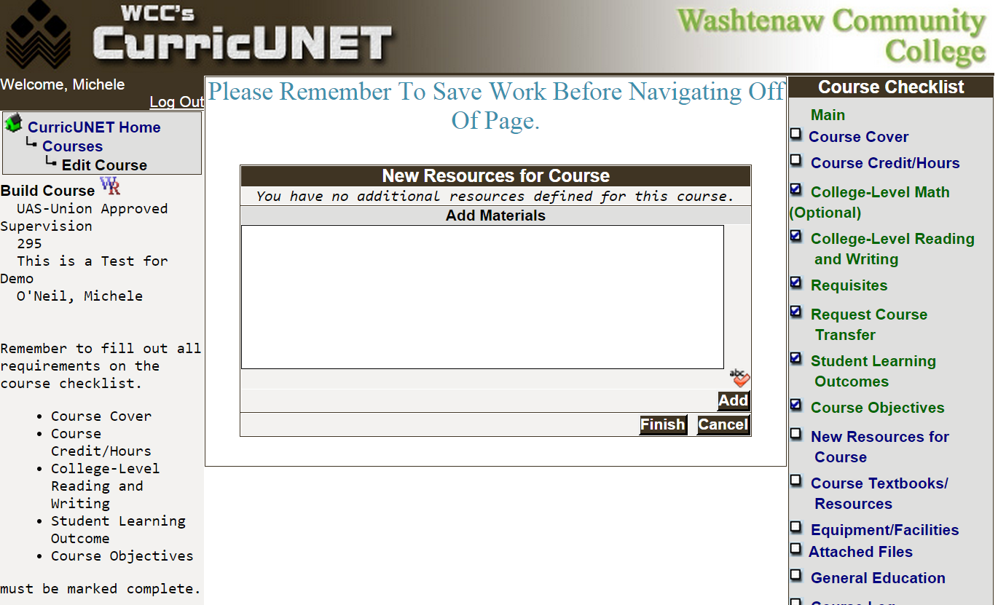
Course Textbooks and Other Resources (Optional)
In the Course Textbook/Resources screen, you will identify textbooks, manuals, periodicals, software and “other” resources for your course.

- Click the Course Textbooks/Resources link on the Course Checklist if necessary.
- Select the option for materials that are required for the course.
- Click Add to open a detailed information section. You may add multiple items in each section by clicking Add again.
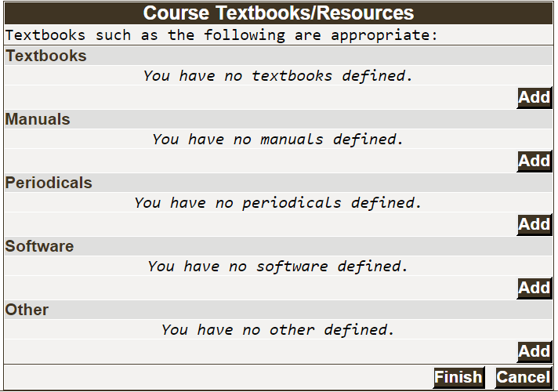
- We will begin with inputting the textbook information.
  - Click Add to enter the required textbook(s) for your course. You will need to add each textbook individually.
  - You are encouraged to input all information but must fill fields with * Indicates Required Field.
  - Input whole dollar amounts only in the Estimated Cost field. If you input the $ dollar sign, it will result in an error. The system will default to $.00 cents.
  - Click Add to add the textbook information to the Master Syllabus.
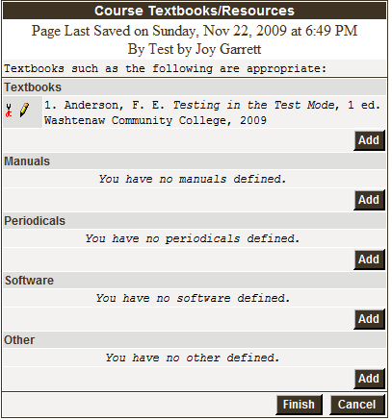
- When all materials have been added, click Finish. This will result in a check appearing next to Course Textbooks/Resources. You will be able to Unlock the page to make additional changes prior to launching the course.
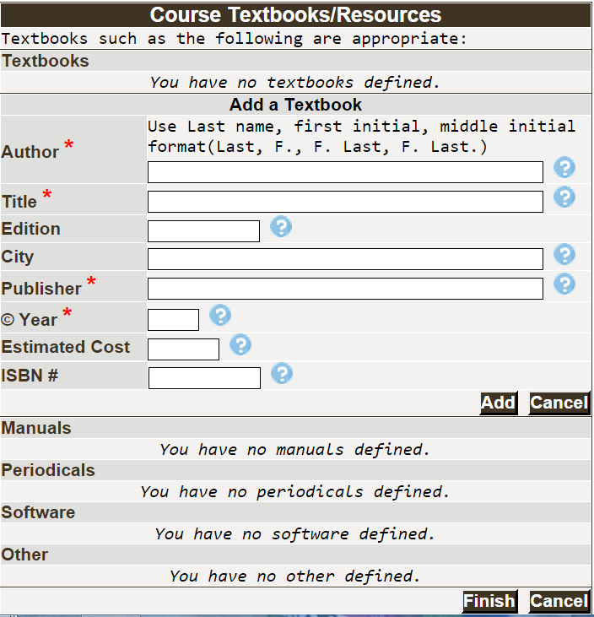
Request Equipment and Room Type (Optional)
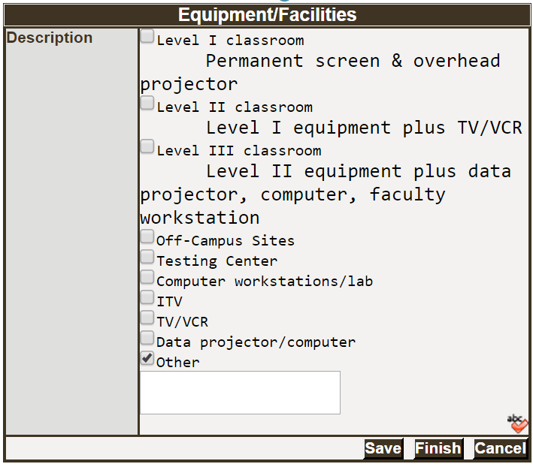
Use the Equipment/Facilities screen to identify room type and equipment that are required in order to teach this course.
- Click on the Equipment/Facilities link in the Course Checklist if necessary.
- Check all boxes that apply. If equipment or room type is not listed, check Other and a text box will become available for you to enter the necessary information.
- When all information has been updated, click Save.
- Click Finish. This will result in a check appearing next to Equipment/Facilities in the Course Checklist. You will be able to Unlock the page to make additional changes prior to launching the course.

Adding Attachments – Optional Sample Questions or Rubrics (Optional)
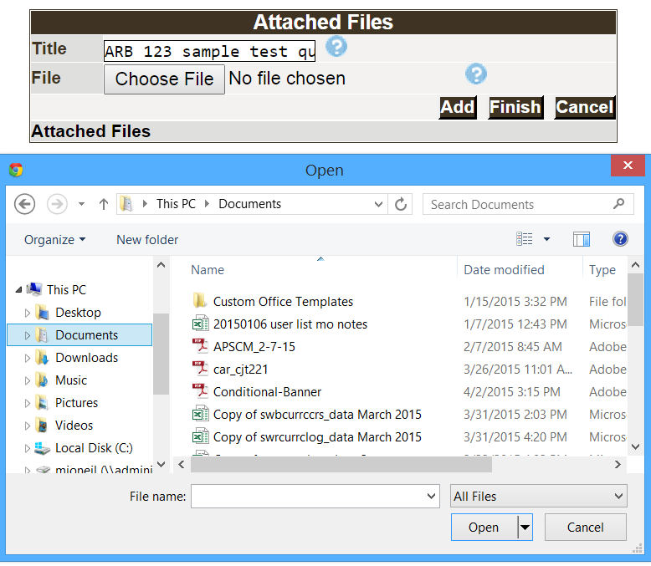
Use the Attached Files screen to attach sample questions, rubrics or other required materials.
- Click on the Attached Files link on the Course Checklist if necessary.
- Give the document that you will be attaching a meaningful name (e.g. ARB 123 sample test questions) in the Title textbox.
- Click on the Choose File button.

- Use the browse feature of your software to locate the saved file.
- Click Add to add the file.
- Repeat the steps above until you have added the necessary files.
- Click Finish when all items have been added. This will result in a check appearing next to Attached Files in the Course Checklist. You will be able to Unlock the page to make additional changes prior to launching the course.

Submit Course into Workflow (Required)
Once you have “Finished” the Course Checklist (adding your new course to CurricUNET), you will see a You may Submit your course now message with the Submit button in the Course Menu on the left-hand side of your screen.
It is important to note that the Submit button appears after you have completed the required sections in the Course Checklist: Course Cover, Course Credit/Hours, College-Level Reading and Writing, Student Learning Outcomes and Course Objectives.
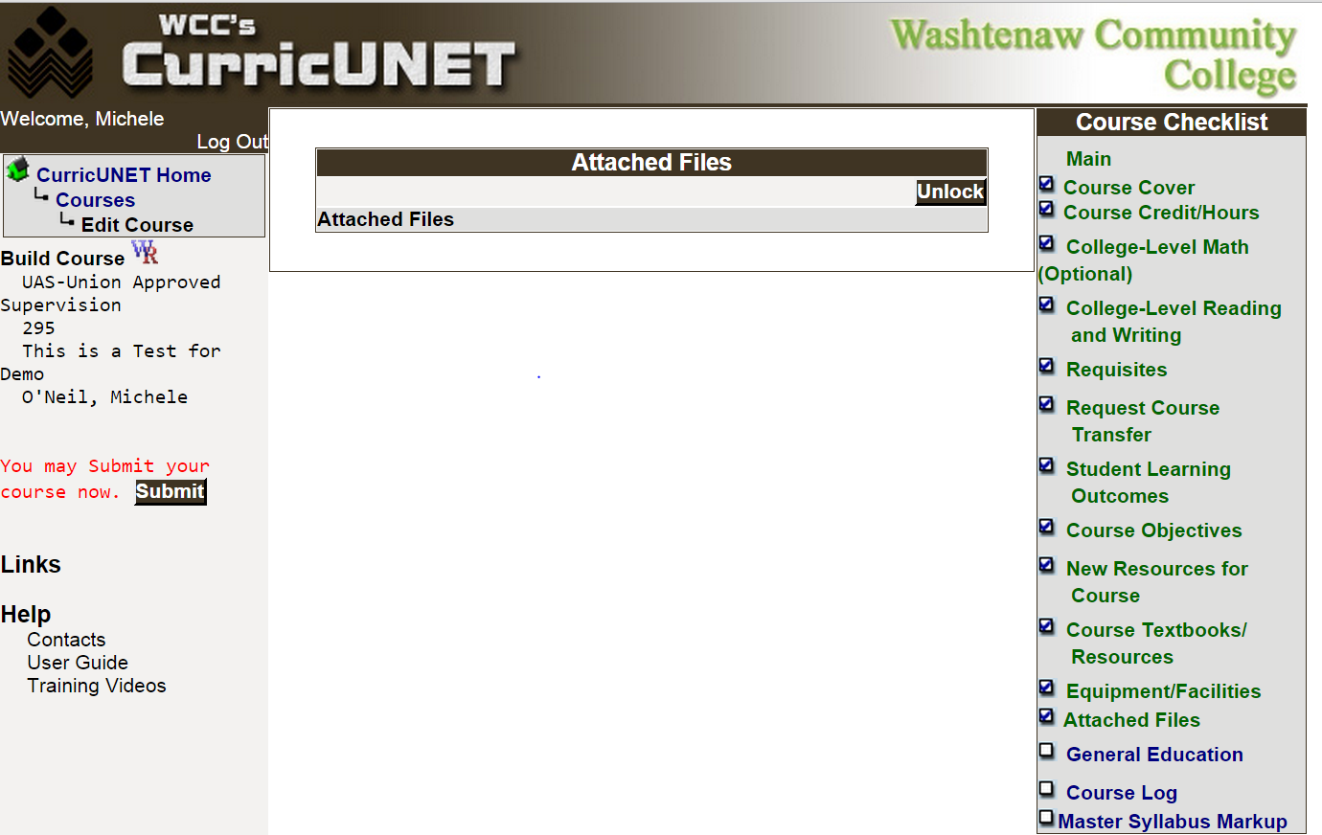
The checks next to the items in the Course Checklist indicate it is complete.
When you click the Submit button, the system will perform an audit and respond with the screen below:
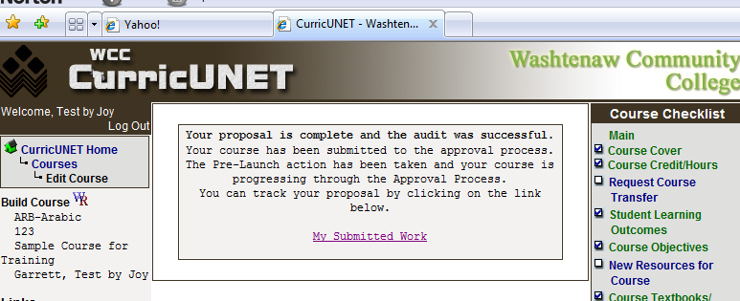
Check the Status of Your Submission
When the course is submitted, the department chair will be notified via e-mail that there is an approval that requires his/her attention and the approval/review process will begin.

Click on the My Submitted Work link on the Main Menu and then click Check Status to see the status of the course in the approval/review process.

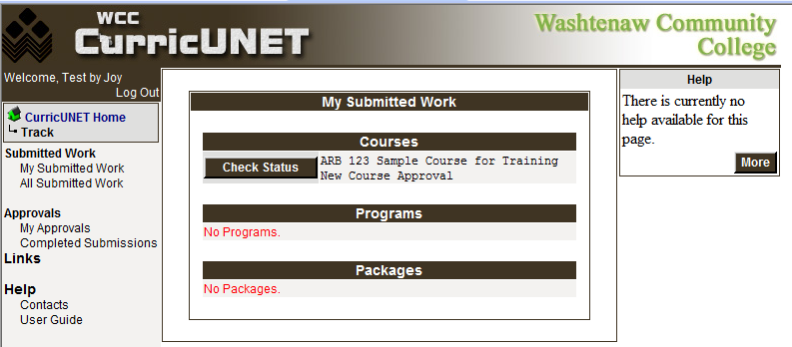
Below is a sample of a course submitted for approval/review and is waiting for the department chair to review and approve it.
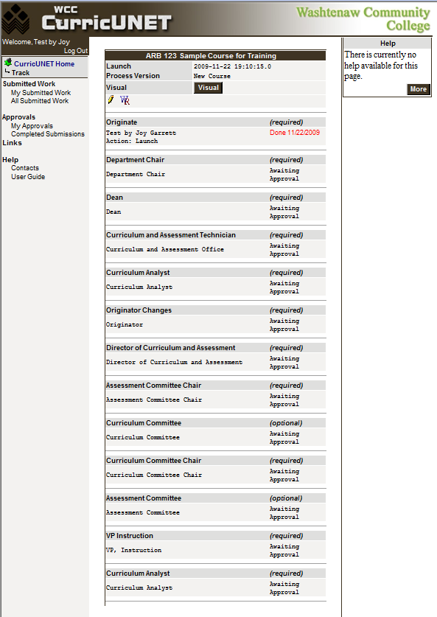
Changes Requested by Faculty Preparer
During the approval process, the Curriculum and Assessment Committees may request changes. You will be notified and can select My Approvals under the Approvals link in the Main Menu.
Click Action for a list of possible responses.
The Pencil icon is available when you need to make changes or corrections to this request.

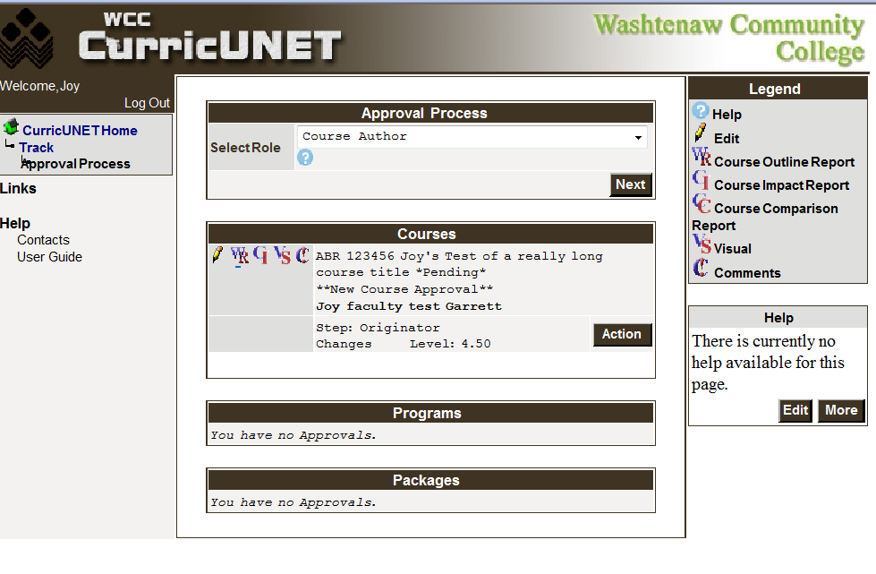
Frequently Asked Questions (FAQs)
- How do I access CurricUNET?
- Open any web browser on any computer that is connected to the Internet. Type on the URL: www.curricunet.com/washtenaw. The Welcome to Washtenaw Community College’s CurricUNET System will appear. Flash is required to use the CurricUNET system. If you do not have Flash Player on your system, an icon will appear allowing you to download the software free.
- Do I have to be on campus to use this software?
- No, it can be used from any computer (PC or MAC) that is connected to the internet. You can access the system from home, from the library or using WIFI.
- How do I sign onto CurricUNET?
- Use your WCC NetId. This is the same Id that you use to sign on to campus e-mail or My WCC. Everyone is assigned a temporary password that should be changed the first time you sign onto the system. In the near future, CurricUNET will be able to validate against WCC’s NetId system, thus expanding our use of the single sign-on. In the meantime, you will need to maintain this password separately.
- What if I can’t remember my password or want to change my password?
- Contact Joy Garrett (jogarrett@wccnet.edu or 973-3374), Michele O’Neil (mioneil@wccnet.edu or 477-8510), or Susan John (sjohn@wccnet.edu 973-3706) during regular business hours. We can help with your password.
- What data was loaded to CurricUNET?
- Between June, 2008 and May, 2009 Lisa Nelson, with the assistance of temporary staff, looked at every printed master syllabus maintained in the Office of Curriculum and Assessment. This information was used to convert to the new system. Because of the nature of the older data, we were liberal in our interpretation of what was an outcome or objective. The first time a course is accessed, you will need to carefully review the data and update it to reflect the current course information.
- What if I need to get this through the process right away?
- An e-mail is generated at each step of the review process to notify the next participant that they need to act. E-mails are accumulated during the day and one is sent each night that includes all of the activities for that day. It is not necessary to wait until the e-mail is sent for the next participant to act. Therefore, you can speed up the review process by contacting the department chair or dean through regular e-mail, with a phone call or an in-person contact asking that they take the necessary action on the submission.
- How will I know when my submission is completed?
- You will continue to receive notification that the submission has been through the review process.
- You said that more processes are being added to the system. How will I know what to do?
- First, we will use the front page of the system to notify you of important information. We can change the text that currently displays “Welcome to Washtenaw Community College’s CurricUNET System”. Watch there for notes. We will use that area to inform you that minor enhancements or modifications have been made to the system.
Second, we will schedule training opportunities and send out a general faculty e-mail when new processes are being rolled out.
Third, additional training materials will be available through User Guide, under Help on the home page.

