Washtenaw Community College
CHANGE or REVIEW COURSES
CurricUNET Training
Revised July, 2015

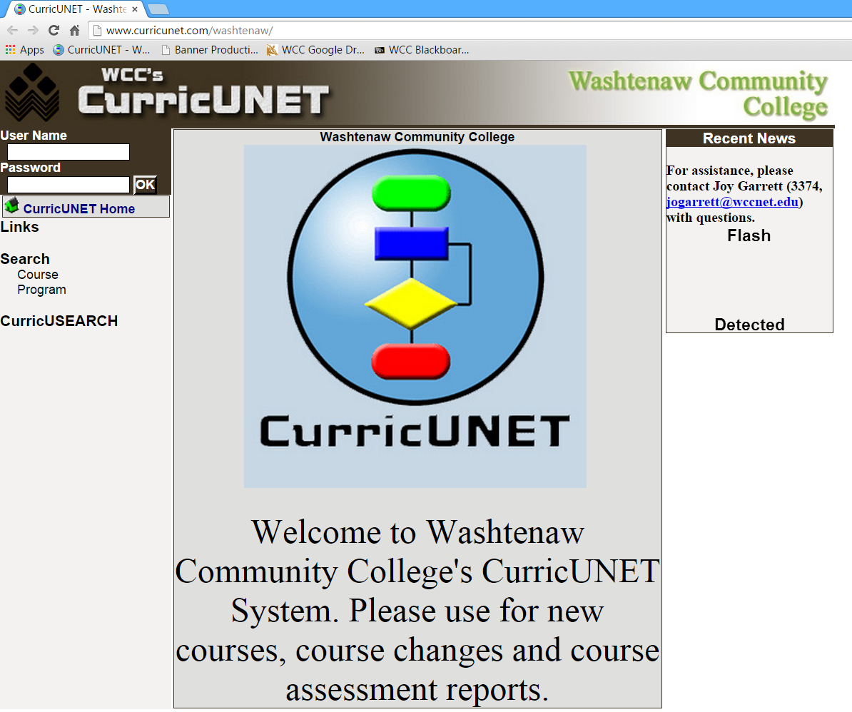
Welcome to Washtenaw Community College’s CurricUNET system. In this document, we will explain how the system will be used to revise a master syllabus.
Sign on to CurricUNET.
- Open a web browser.
- Type www.curricunet.com/washtenaw to bring up the WCC CurricUNET homepage.
- Type in your User Name (same as your WCC net id) and Password.
- Click OK



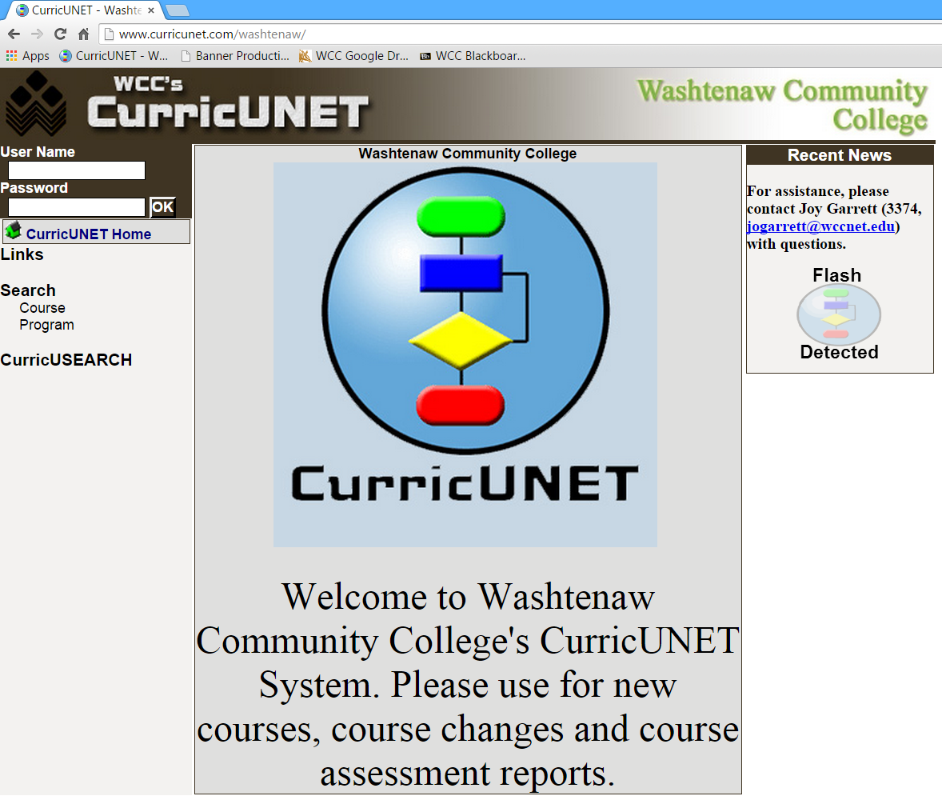

Main Menu Bar
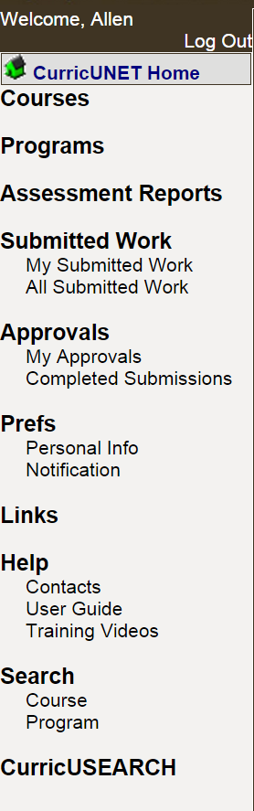 | Log Out – Logs you out of CurricUNET.  CurricUNET Home – The CurricUNET Home button takes you to the Home Page, main menu, of CurricUNET. This page provides an entry point into the system.  Courses – You may build a new course, update an existing course or inactive a course.  Programs – This is a future feature to be implemented at a later date.  Assessment Reports – Create or edit an assessment report.  Submitted Work – You may see your submitted work or college-wide submitted work.  Approvals – Area where you can track your approvals and proposals.  Prefs – Edit your personal information.  Help – The Help area contains important contact information and the CurricUNET User Guide and training videos.  Search – The Search area is where all WCC course searches are conducted.  The CurricUSEARCH area allows you to search for course outlines at other nationwide campuses that utilize CurricUNET.
Explanation of Symbols
Legend
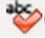
Spell Check
Help
Copy
Edit
Delete
Move Item Up
Move Item Down
* Indicates Required Field
Course Impact Report
Course Outline Report
Course Changes Report
Course Syllabus
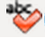
Spell Check – Located in most boxes requiring you to enter information, click this symbol in the body of the screen to initiate spell checking.
Help – Click this symbol to read additional information about the section or task being completed.
Edit – Click this symbol to edit the listed item.
Delete – Click this symbol to delete the listed item. The system will ask you to confirm that you want to delete the item. If you confirm, it is permanently deleted and cannot be retrieved.
Move Item Up
Move Item Down – Use these arrows to move an item up or down in a listing.
* Indicates Required Field – You will not be able to save your data or move on to the next area unless you fill in all required fields.
Copy – Click this symbol to copy the listed item and begin to edit the course. A new version of the master syllabus is created for your use.
Course Outline Report – Click this symbol to view the CurricUNET version of the WCC Master Syllabus.
Course Changes Report – Click this symbol to view the Course Changes Report.
Course Impact Report – Click this symbol to view the Course Impact Report.
Course Syllabus – Click this symbol to view the Course Syllabus.
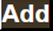
Add – Adds an item and allows to to add a second item without close the current screen.
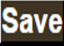 Save – Saves your work without closing the current screen.
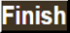 Finish – Closes the current screen and completes the current section.
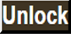 Unlock – Allows you to edit the previously finished/saved section.
Change/Revise a Current Course
- Click on Courses from the main menu to access the Course Submenu.
- In this example, select Update Existing Course from the Course Submenu. Below are the actions that you may perform in the Course Submenu:
- Build New Course (see New Course Submission Training Manual)
- Update Existing Course – this includes a 3-year review or course change
- Inactivate Course – Change a course that is not currently in use to an inactive status. Courses can be reactivated using a process similar to update existing course.

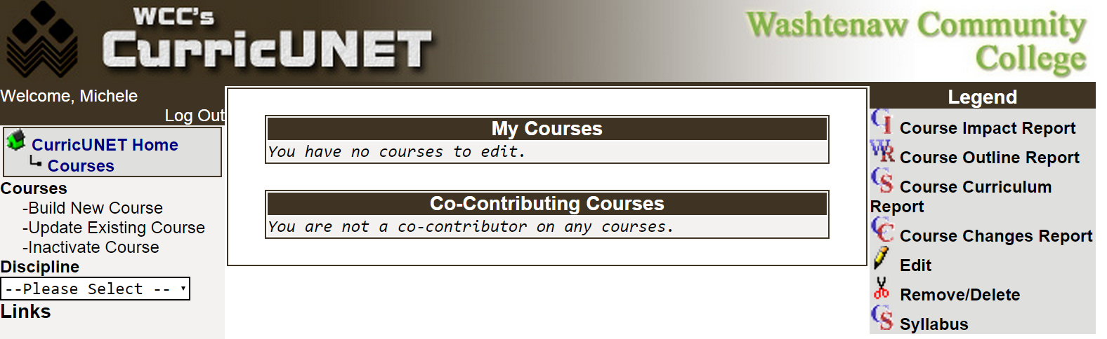

- Select the appropriate Discipline from the dropdown boxes.
- Once the discipline has been selected, click OK.
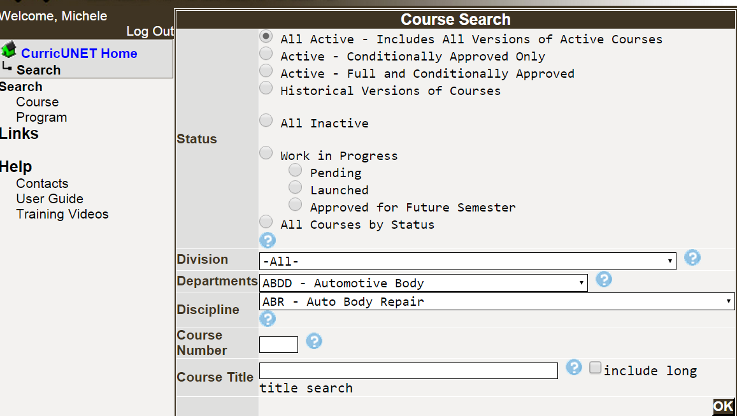

Copy the Course to be Changed/Revised

- Copy the Course you wish to update, inactive, change or revise by clicking on the Copy icon.

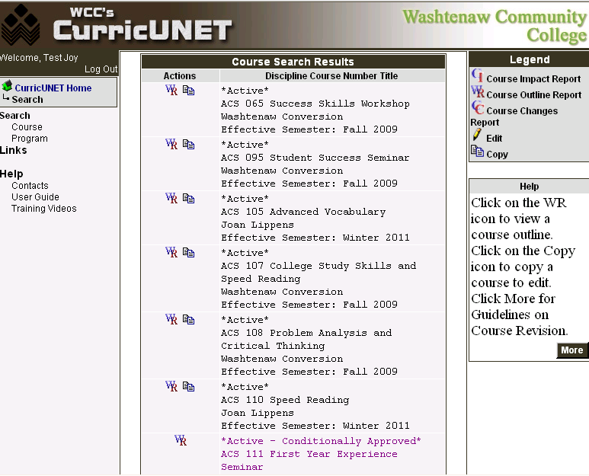

NOTE: There are two reasons why the Copy symbol will not appear next to a course.
  - If you do not have access to that discipline, the copy function will not appear.
  - If the course revision has been initiated by another user, the copy function will not appear.
EXAMPLE: ACS 111 does not have a copy icon next to it. That course has been copied and a faculty member is already in the process of updating that course.

- Select the Proposal Type, the changes being made the course, from the dropdown box. Your choices are Reactivation of inactive course, Course Change, Course Inactivation or Three-year syllabus review.
- Leave the Change Information with the default information. These values will be updated by the Office of Curriculum and Assessment.
- Click Next.
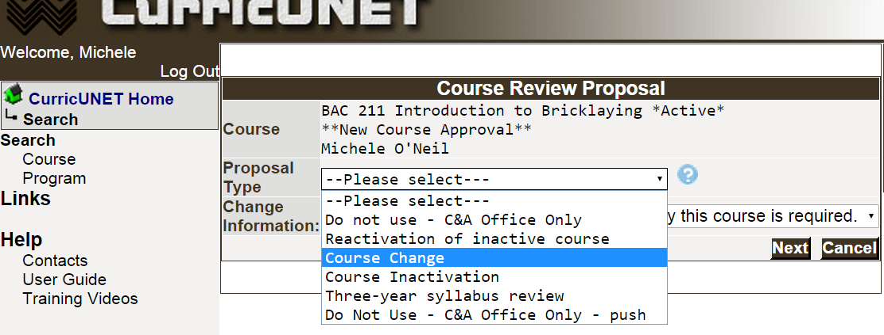
- Explain the Rationale behind the changes being initiated. Spell check is available by clicking
the Spell Check icon.
- Click OK.

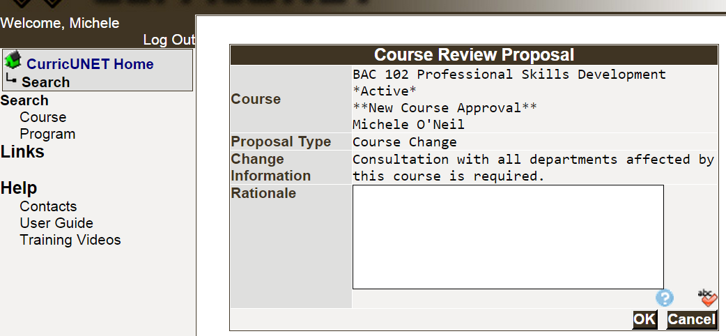

- Because the system is now copying the complete course, you may experience a brief delay. Do not panic.

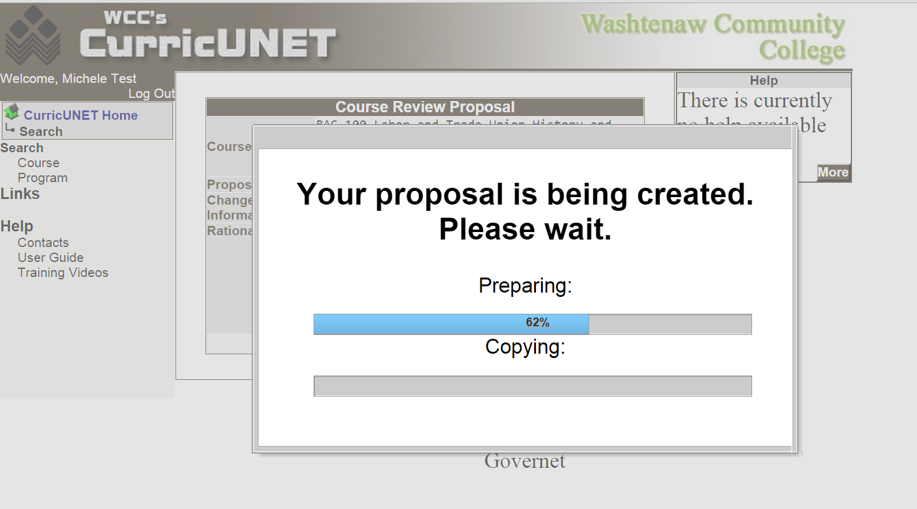

  - If the copy were to fail, you will receive an error message.
  - Once the course has been successfully copied, the next screen to appear is the Course Construction Main Menu.
Course Construction Main Menu

On the Build Course Main Menu, you can add a co-contributor. This would be an individual that you want to have update access to the new course you are building. You will click on the Add a Co-Contributor link, and it will prompt you to select a user name and identify the screens/sections that the individual will be allowed to update. You are not required to add a co-contributor.

Course Checklist

Use the Course Checklist on the right side of the Build Course Main Menu to select the next action you wish to take. It is your navigation through the update/revise a course process. You are encouraged to follow this checklist in order. Each time that you Finish a section/item in the Course Checklist, a check will appear to indicate that section has been completed. Below is a summary of the required and optional sections:

Course Checklist Section/Item | Optional or Required
Course Cover | Required
Course Credit/Hours | Required
College-Level Math | Optional
College-Level Reading and Writing | Required
Requisites | Optional
Request Course Transfer | Optional
Student Learning Outcomes | Required
Course Objectives | Required
New Resources for Course | Optional
Course Textbooks/Resources | Optional
Equipment/Facilities | Optional
Attached Files | Optional

Begin the Course Cover by clicking on the Course Cover link in the Course Checklist. Hint: Do not click on the checkbox next to the link.

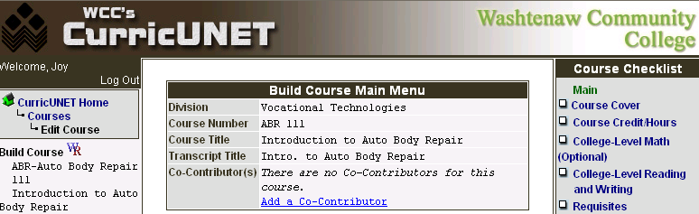

Edit Course Cover Information

All information currently stored in the database will appear. You will edit only the information that has changed or was not available to the conversion.

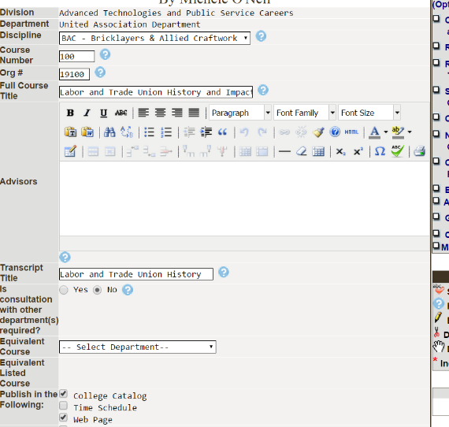
- Revise Org. # (Banner Org number). Contact your department chair or dean with questions.

- Revise the Full Course Title and the Transcript Title if needed.
- If there is an Equivalent Course, select it from the dropdown box.
- Check the appropriate boxes in the Publish in the Following if the course should be published in the catalog, time schedule or on the web page. Most courses should appear in all three.


NOTE: The Curriculum and Assessment Office will input the Reason for Submission and Change Information.

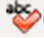
- Revise the Course Description if needed. Use the Spell Check icon to initiate the spell check function.
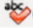
- Edit the Rationale. Include how the course will fit into an existing program(s) if appropriate. Click on the Spell Check icon to initiate the spell checker.
- Select the Proposed Start Semester from the drop down and type the proposed start Year.
- Save before you navigate from this page. When you are satisfied with the information on this page, you should click Finish. This will result is a check appearing next to Course Cover in the Course Checklist.





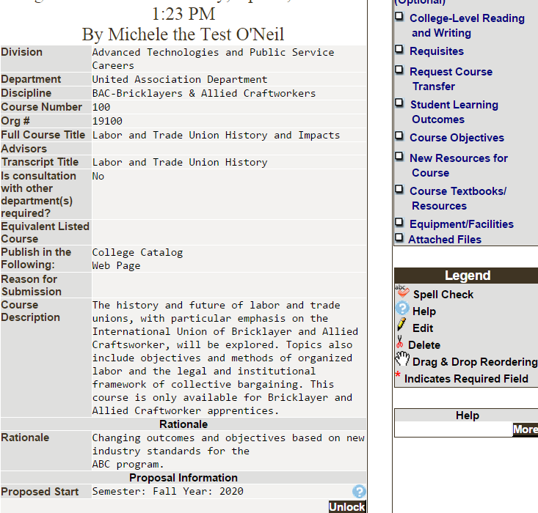
- Prior to launching the course, you will be able to Unlock the page to make additional changes or corrections. 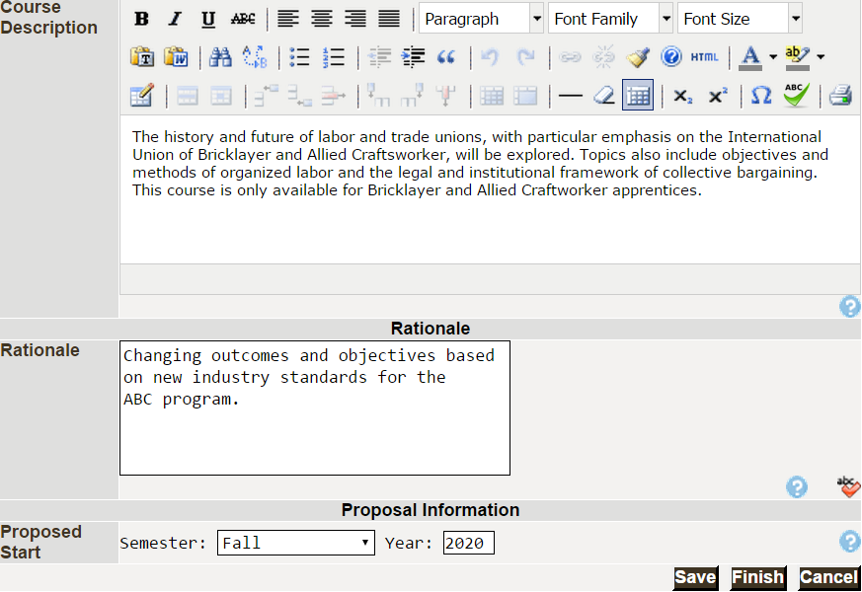
Edit Credit and Contact Hours and Grading Options

If the course can be offered for variable credit, please contact the Office of Curriculum and Assessment.
- The system will default to No for Variable Hours.
- Revise the credit hours in Credits as needed.
- Contact Hours for standard (not variable) credit:
  - Revise the Contact Hours as needed for both the student and instructor boxes according to the guidelines below:
    - Lecture Hours (generally 1 credit hour = 15 contact hours of lecture)
    - Lab hours if used (generally 1 credit hour = 45 contact hours of lab)
    - Clinical hours if used
    - For Describe Other Contact Hours, type the hours for both the student and the instructor if they do not fall under one of the categories above. A textbox will appear for you to explain the hours.
  - The Total Contact Hours will be calculated by the system. To adjust the total hours, you must change a value in either lecture, lab, clinical or other.
- Review the Schedule Type. A reminder that the Delete icon permanently removes the option.
- The default is NO for Repeatable for Credit. Click YES and a box will appear in which to record the number of times the course can be repeated for credit. A course that can be repeated for credit does not allow students the opportunity to repeat a course for a better grade.
- Review the Grading Methods. Most courses 100 or above are taught for Letter Grades and can be audited. Do not use Transfer.


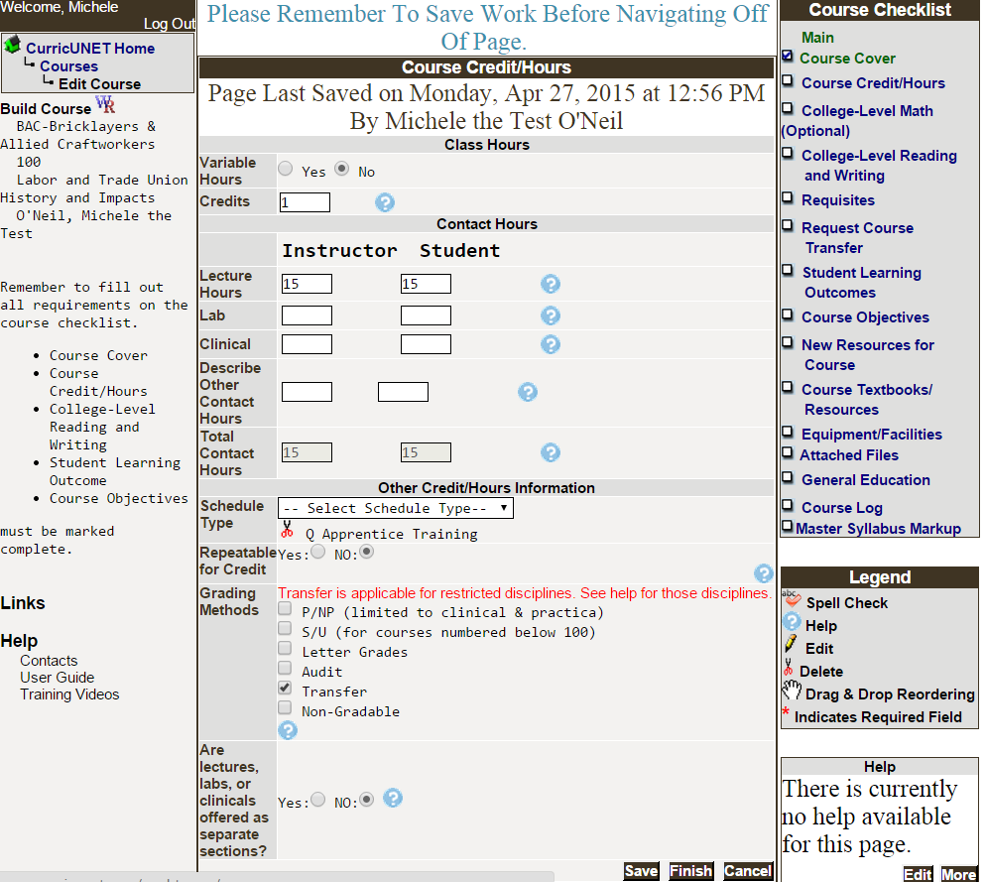
- Indicate if the lecture and lab are taught in separate sections. The system will default to NO.

- Click on Save before you navigate from this page. When you are satisfied with the information on this page, click Finish. This will result in a check appearing next to Course Credit/Hours in the Course Checklist. Prior to launching the course, you will be able to Unlock the page to make additional changes.
Optional College-Level Math

For courses that have a math level requirement, you may enter those in the College-Level Math (Optional) section. For a description of math placement scores and courses, access the Math Department’s web site at http://departments.wccnet.edu/math/.

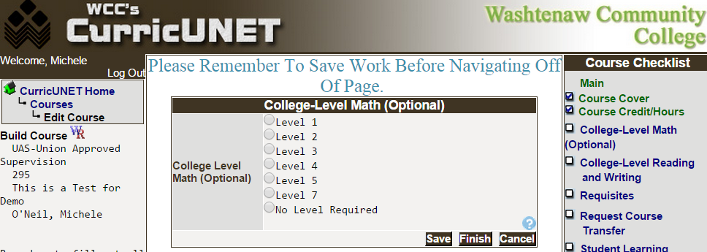

Be sure to click on Save before you navigate from this page. When you are satisfied with the information on this page, click Finish.

Modify Reading and Writing Levels

- Select the appropriate reading and writing level to edit. Only one level may be selected. If the level that applies to your course is Reduced Reading/Writing Scores, you will enter those scores in the Requisites section of the Course Checklist.
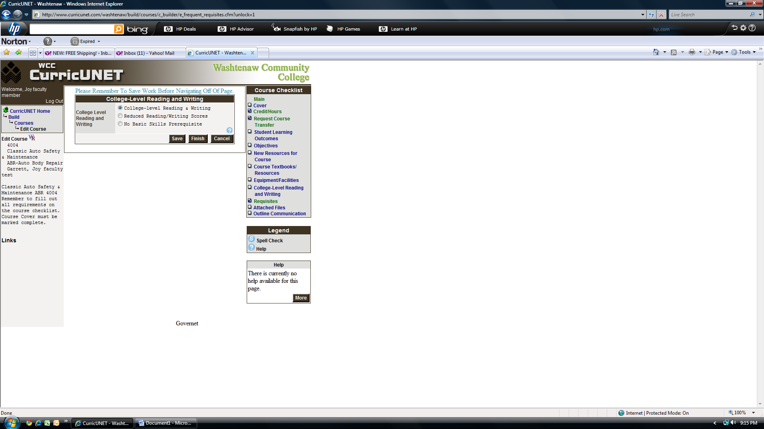
- Click Save before you navigate from this page.
- When you are satisfied with the information on this page, click Finish. This will result in a check appearing next to College-Level Reading and Writing in the Course Checklist.

Requisites – Prerequisites, Co-requisites and Enrollment Restrictions
To modify an existing requisite, click on the Edit option next to the Requisite that you want to edit. Revise as needed.

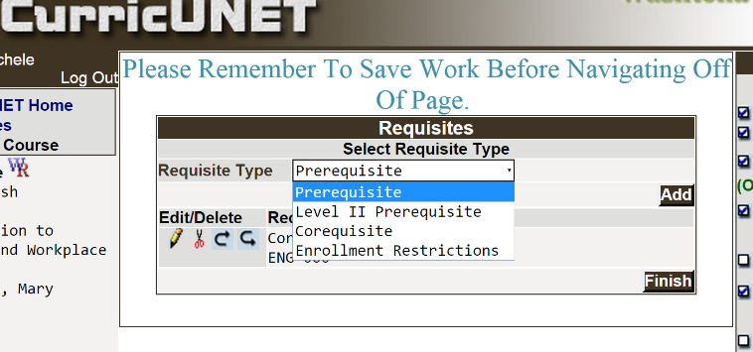
To add a Requisite, select the Requisite Type from the drop down box and click Add. If your course has Reduced Reading/Writing Scores, those scores are added as a Prerequisite type. A sample for adding a Prerequisite is in the next section.
Sample – Add or Edit a Prerequisite
- Select Prerequisite as the Requisite Type from the Requisites menu and click on Add if you have not already done so.
- If the prerequisite is a WCC course, select the course from the dropdown box.
- Enter a minimum grade in the Min Grade field if the student must earn a grade higher than the default of D-.
- Check the Concurrent Enrollment box if the student may take the prerequisite at the same time.
- Describe the prerequisite if it is not a WCC course.in the Comment or Non Course requirement textbox. An example for when to use this textbox is providing Reduced Reading/Writing Scores.
- If more than one prerequisite will be required, select the Condition “and” or “or.”


- Click Add to add the prerequisite.
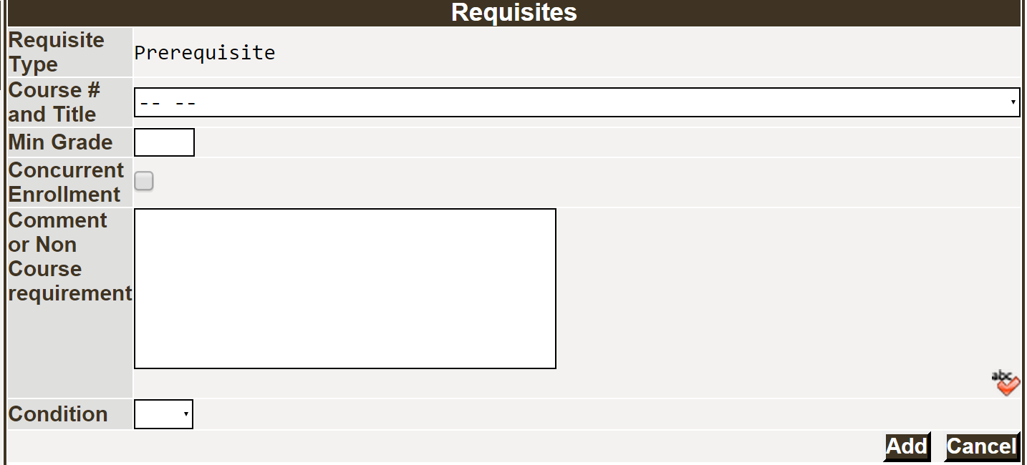
- Click Finish. This will result in a check appearing next to Requisites in the Course Checklist. You will be able to Unlock the page to make additional changes prior to launching the course.

Optional Request Course Transfer Equivalency Review
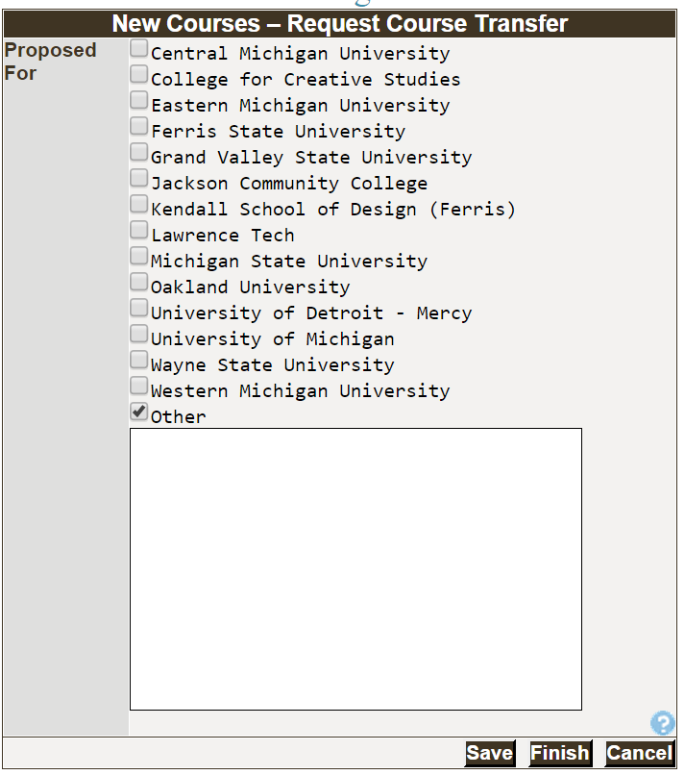
- For courses with a significant change to the content, please select schools where the course might transfer.
- If a school is not listed, click Other and a textbox will appear to input the name of the school.
- Click Save.
- When you are satisfied with the information on this page, you should click Finish. This will result in a check appearing next to Request Course Transfer in the Course Checklist. You will be able to Unlock the page to make additional changes prior to launching the course.

Add or Revise Student Learning Outcomes
An important note when working with this section: student learning outcomes are added one at a time in CurricUNET. A description of outcome language, tools and scoring methods can be found by clicking on the Taxonomy link in the Course Checklist. The Taxonomy document will open in a new window. You will either Add or Edit the student learning outcomes. Remember, use the Spell Check icon to check spelling as needed.
- To Add an outcome, type the outcome, using measurable language, in the Outcome Text box. Click Add to add the outcome. |   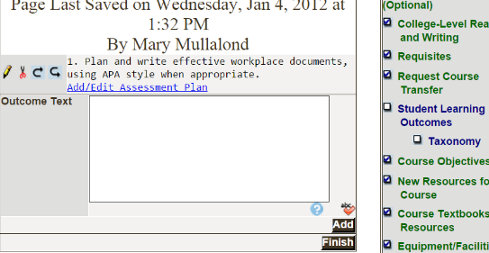
- To Edit an outcome, click the Edit option. The text will appear in the Outcome Text Box. Revise as needed and then click the Save button. |   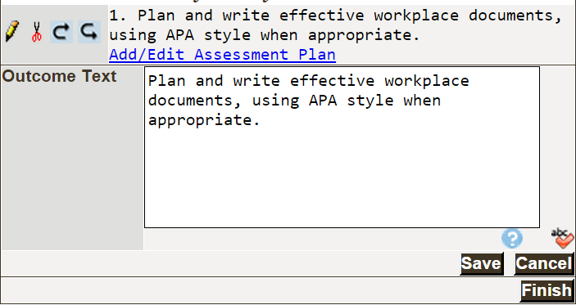
- Repeat adding and/or editing the outcomes as needed.
Once all of your student learning outcomes are correct, you will add the assessment plan information in the next section.

Revise or Add Assessment Plan Details for Each Outcome
- Click on the Student Learning Outcomes link in the Course Checklist if necessary to access the Assessment Plan.
Note that you can change the order of the outcomes, edit an outcome or delete it by clicking on the appropriate edit icons.

- Whether you are adding an assessment plan or editing, it is the same process. Click on the Add/Edit Assessment Plan link below the Student Learning Outcome.
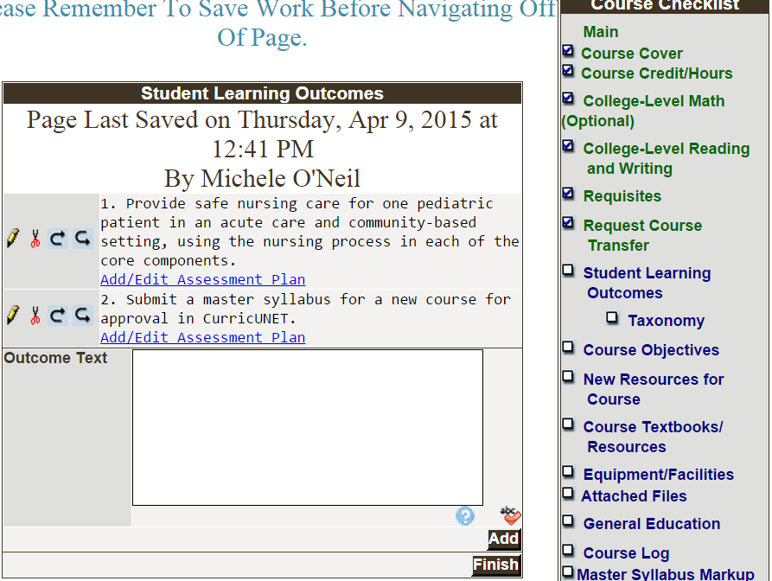

        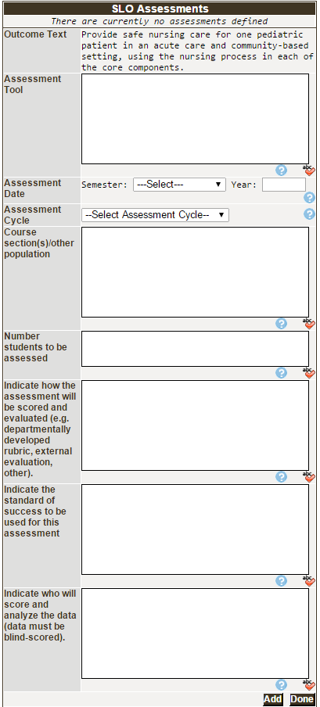 | 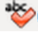  Remember to use Spell Check as needed when typing in the textboxes.  The Outcome Text appears above the Assessment Tool.  - Enter the Assessment Tool that will be used to assess the outcome (e.g., test, written essay, performance, etc.).  - Indicate the Assessment Date (Semester and Year) when you plan to assess the course.  - Select the Assessment Cycle from the dropdown box.  - Identify the Course section(s) or other population you will select to assess.  - Indicate the Number of students to be assessed.  - Indicate how the assessment will be scored and evaluated (e.g. departmentally-developed rubric, external evaluation, other).  - Indicate the standard of success to be used for this assessment.  - Indicate who will score and analyze the data (data must be blind-scored whenever possible).  - When you are satisfied with the information on this page, click Add.
- Assessment Plan:
  - The Assessment Tool that was entered will appear under the Outcome Text.
  - To see the details of that Assessment Plan, click on the Edit icon and the boxes will be populated. Assessment data that was previously submitted was available in the old system for conversion. If an assessment method was converted, it will appear at the bottom of this page. To see the details of that method, click on the Edit and the boxes will be populated.
  - To copy the Assessment Plan to another outcome, select the copy icon.



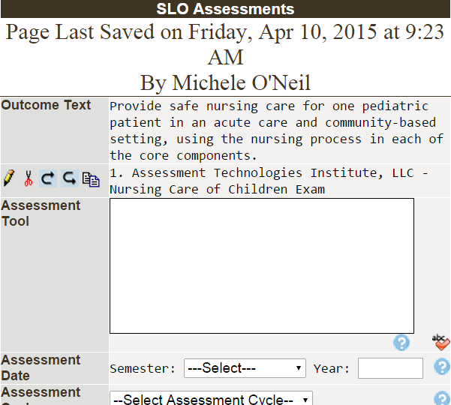
- Add another assessment tool if needed to the appropriate Student Learning Outcome.
- When all assessment tools have been added for an outcome, click Done. You will return to the Student Learning Outcomes page.
- When you have updated all outcomes and the associated assessment information, click Finish. This will result in a check appearing next to Student Learning Outcomes. You will be able to Unlock the page to make additional changes prior to launching the course.
Copy Assessment Plan to Another Outcome
An enhancement to the CurricUNET system allows faculty to copy an assessment plan from one outcome to another. This feature will save significant input time when the plans are substantially the same.

- After using the copy function on the SLO Assessments screen, the SLO Assessment Copy screen will appear.
- Select the outcome from the dropdown menu to which you want to copy the assessment plan to.
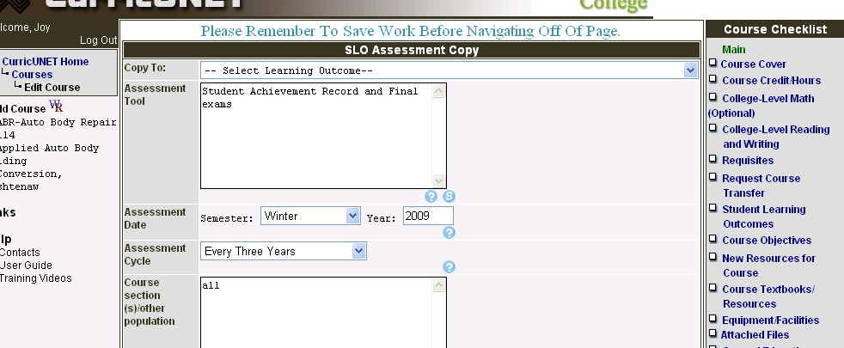
- Click Save (not shown here - at the bottom of the screen).
- You will return to the original SLO Assessments page, which will display the original outcome and the original assessment plan (not the one that you copied to). You may copy the assessment plan to another outcome and repeat the process until completed.
- Click the Done button when finished and you will return to the Student Learning Outcomes section.

Add or Edit Course Objectives
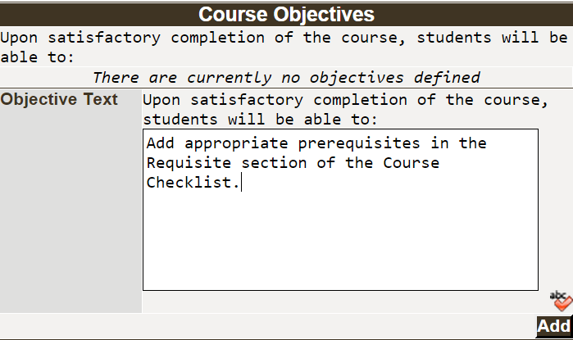
Course Objectives are added one at a time. Click the Course Objectives link in the Course Checklist if necessary to access. There is also a link to Taxonomy document in the Course Checklist.

- Type the first objective using measurable language in the Objective Text box. Use the Spell Check icon to check spelling.
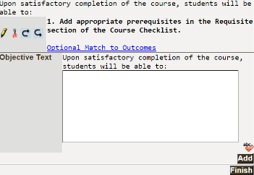
- Click the Add button. Repeat the process of adding each course objective individually.
- You may edit the Course Objectives by using the Edit icons.
- When you have finished adding all of your course objectives, click Finish. A check will appear next to Course Objectives in the Course Checklist. Remember, you can edit any section of the Course Checklist by clicking on the section link and Unlock.
- It is important to note that we are no longer matching the course objectives to the outcomes.
Identify New or Edit Existing Resources for Course (Optional)
You may use this text box to identify new resources (equipment, faculty, learning resources material, etc.) that are required in order to teach this course. You must still follow the regular procedures to request resources through your department.
- Click on the New Resouces for Course link on the Course Checklist if necessary.
- When all information has been added in the Add Materials textbox, click Add.
- Click Finish. This will result in a check appearing next to New Resources for Course. You will be able to Unlock the page to make additional changes prior to launching the course.
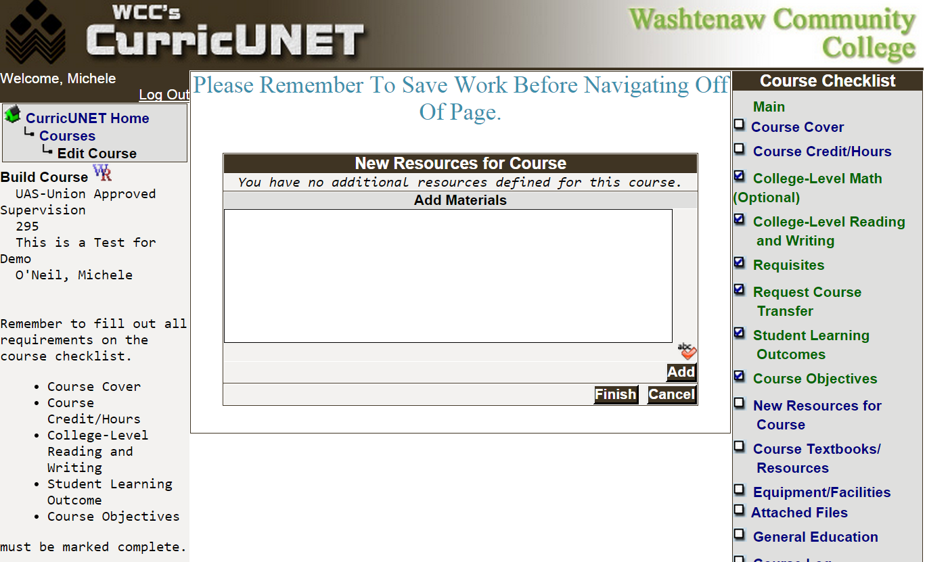
Add or Edit Course Textbooks and Other Resources (Optional)
In the Course Textbook/Resources screen, you will identify or edit textbooks, manuals, periodicals, software and “other” resources for your course.

- Click the Course Textbooks/Resources link on the Course Checklist if necessary.
- Select the option for materials that are required for the course.
- Click Add to open a detailed information section. You may add multiple items in each section by clicking Add again.
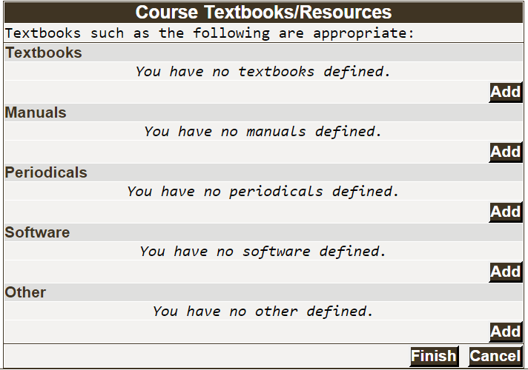
- We will begin with inputting the textbook information.
  - Click Add to enter the required textbook(s) for your course. You will need to add each textbook individually.
- You are encouraged to input all information but must fill fields with * Indicates Required Field.
- Input whole dollar amounts only in the Estimated Cost field. If you input the $ dollar sign, it will result in an error. The system will default to $.00 cents.
- Click Add to add the textbook information to the Master Syllabus.
- To edit, click on the edit icon next to item you wish to edit.
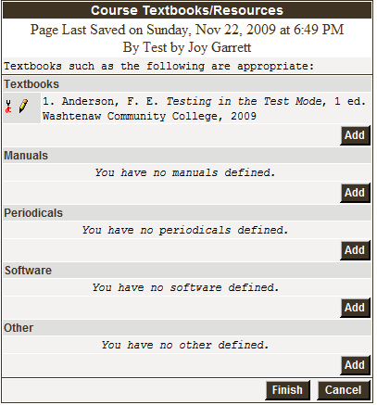
- When all materials have been updated, click Finish. This will result in a check appearing next to Course Textbooks/Resources. You will be able to Unlock the page to make additional changes prior to launching the course.
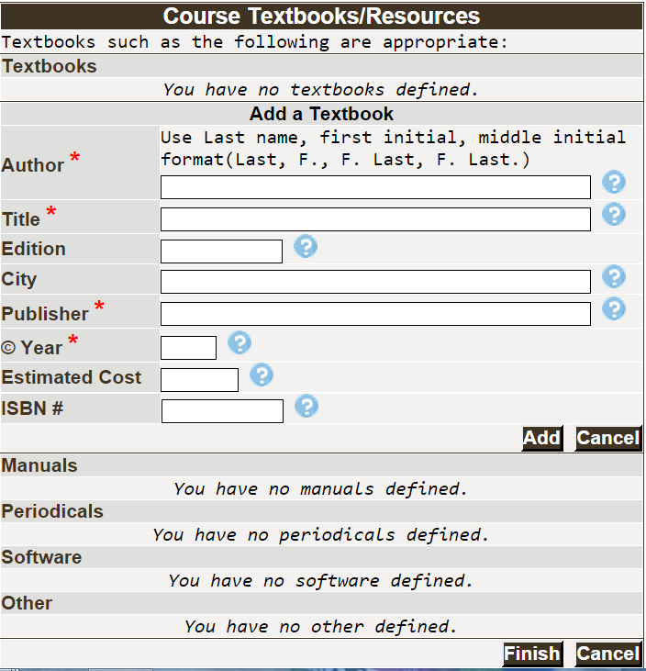
Request Equipment and Room Type (Optional)
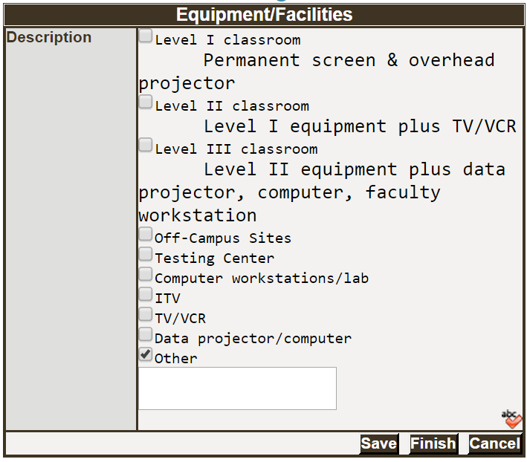
Use the Equipment/Facilities screen to identify room type and equipment that are required in order to teach this course.
- Click on the Equipment/Facilities link in the Course Checklist if necessary.
- Check all boxes that apply. If equipment or room type is not listed, check Other and a text box will become available for you to enter the necessary information.
- When all information has been updated, click Save.
- Click Finish. This will result in a check appearing next to Equipment/Facilities in the Course Checklist. You will be able to Unlock the page to make additional changes prior to launching the course.

Adding Attachments – Optional Sample Questions or Rubrics (Optional)
Use the Attached Files screen to attach sample questions, rubrics or other required materials.

- Click on the Attached Files link on the Course Checklist if necessary.
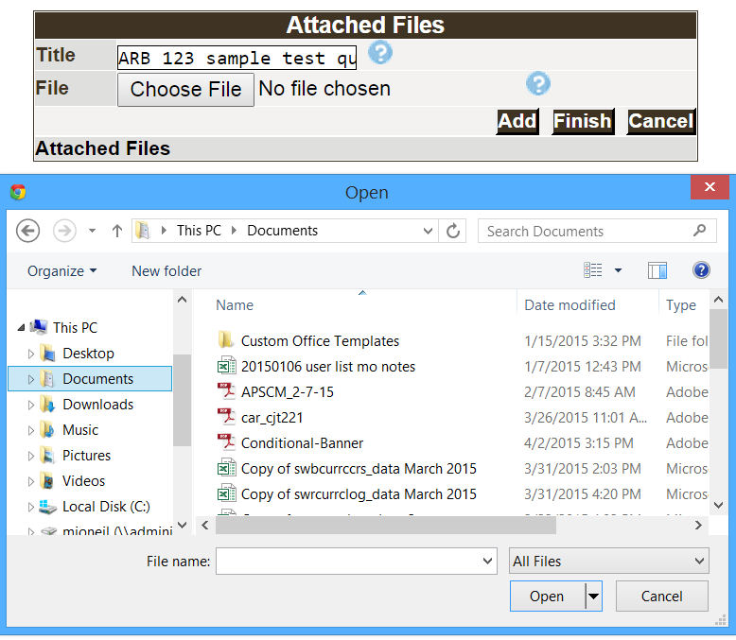
- Give the document that you will be attaching a meaningful name (e.g. ARB 123 sample test questions) in the Title textbox.
- Click on the Choose File button.
- Use the browse feature of your software to locate the saved file.
- Click Add to add the file.

- Repeat the steps above until you have added the necessary files.
- Click Finish when all items have been added. This will result in a check appearing next to Attached Files in the Course Checklist. You will be able to Unlock the page to make additional changes prior to launching the course.

Submit Course into Workflow
Once you have “Finished” the Course Checklist, you will see a You may Submit your course now message with the Submit button.
It is important to note that the Submit button appears after you have completed the required sections in the Course Checklist: Course Cover, Course Credit/Hours, College-Level Reading and Writing, Student Learning Outcomes and Course Objectives.
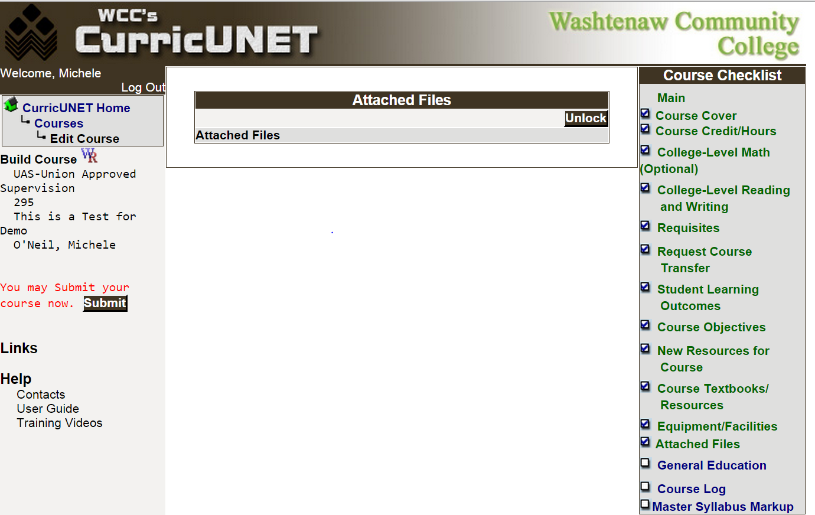
The checks next to the items in the Course Checklist indicate it is complete.
When you click the Submit button, the system will perform an audit and respond with the screen below:
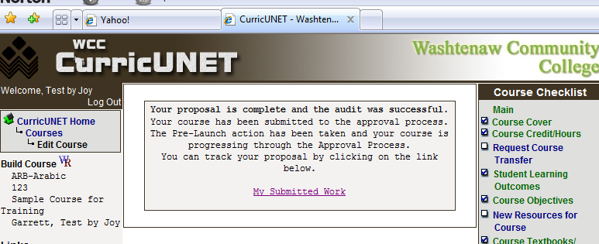
Check the Status of Your Submission
When the course is submitted, the department chair will be notified via e-mail that there is an approval that requires his/her attention and the approval/review process will begin.

Click on the My Submitted Work link on the Main Menu and then click Check Status to see the status of the course in the approval/review process.

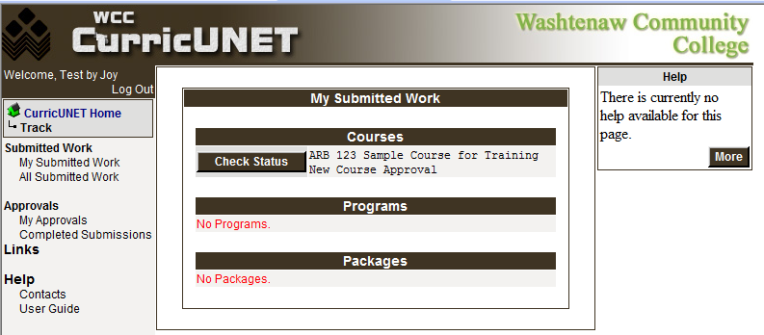
Below is a sample of a course submitted for approval/review and is waiting for the department chair to review and approve it.
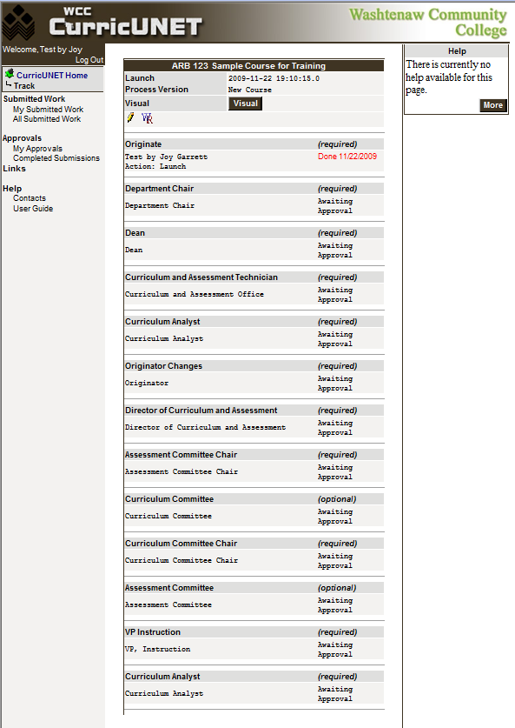
Changes Requested by Faculty Preparer
During the approval process, the Curriculum and Assessment Committees may request changes. You will be notified and can select My Approvals under the Approvals link in the Main Menu.
Click Action for a list of possible responses.
The Pencil icon is available when you need to make changes or corrections to this request.

